**ONLINE HOME ENERGY MONITORING AND POWER SOCKETS CONTROL SYSTEM**

**In partial fulfillment of the Requirements for the Degree of**

**Bachelor of Science in Information Technology**

**at**

**Bulacan State University**

**By**

**Catindig, John Gerard C.**

**Dangca, John Basti B.**

**Dela Cruz, Erick Dave B.**

**Francisco, John Benedict D.**

**Marcena, Alfred Jonas C.**

**November 2018**

# **Abstract**

Online Home Energy Monitoring and Power Sockets Control System is a mobile application with Power Socket Unit that helps households in monitoring their electricity consumption and to avoid electricity hazards caused by unattended appliances that are consuming electricity while the user was away from home. The power socket unit uses RFID to register appliances and to detect unauthorized people from plugging in it. The user can monitor the electricity consumption for each appliances that are registered on the system’s database through the mobile application that remotely access the power socket through the internet. It has a feature that remotely switches the power socket on or off. It also notifies the user if an appliance is plugged in whether it is registered or unregistered.

The proponents used the AGILE Scrum Methodology to develop the software. As the proponents develop the system, they used different technologies such as Cordova Framework, HTML/CSS, Javascript, PHP and ArduinoC. To utilize those technologies, the proponents used different development tools such as Sublime Text, Notepad++ and XAMPP.

During the implementation stage of the Online Home Energy Monitoring and Power Sockets Control System, the proponents assessed the feasibility of the project by allowing users to evaluate the system. 40 users evaluated the system in which 87.5% being the possible users of the system and some of them are IT Students and the remaining 12.5% are IT Experts. After conducting the evaluation, the results are then tallied to compute for the general weighted average of 4.35 with the response description of “Very Good”.

# **Chapter I**

## **INTRODUCTION**

This chapter contains the problems that this project aims to solve, the purpose of creating the product, and how the proponents formulated the idea and came up with the project proposed. The objectives the proponents achieved as the proponents pursued the projects, the scope and limitation, and the importance of the completion of the study.

### **Project Context**

Electricity is one of the most important blessings that science has given to mankind. It has also become a part of modern life and one cannot think of a world without it. Electricity has many uses in our day to day life. It is used for lighting rooms, working fans and domestic appliances like using electric stoves, air-conditioning units and more. All these provide comfort to people.

It is undeniable that the benefits of Electricity are outstanding and become a necessity in living comfortably. A typical household life will hardly exist without the presence of electricity. With more and more devices requiring the use of internet in order to function, the proponents provide solutions to the ever-increasing need of monitoring the power consumption of each individual household, however a typical household can control the data provided resulted by monthly electricity bill and once an individual pays more attention with monitoring, it will be easy to control and save electrical consumption.

Electricity consumption may cause not only an improved living style but also aggravated impacts on the environment due to inappropriate use. Hence, relevant energy policies are required to induce efficient electricity consumption in the residential sector in many countries due to global warming effects and security of energy supply. As the electricity consumption in the residential sector accounts for about one third of the total electricity consumption in the world, this implies that the electricity consumption characteristics in households and residential sector should be focused (Yi-Tui Chen, 2017, p. 2).

According to the World Fact Book of the Central Intelligence Agency, as of 2016 the Philippines has an estimated consumption of 74.15 billion kWh which amounts more than 711 Billion Pesos in revenue using February 2017 Data Presented in the webpage of Meralco.

As the population Increase, the demand for electricity also increases, according to Philippine Statistic Authority. Electricity is the most common source of energy used by the household on the study that they released on the December 27, 2013 with about 87 percent of 21.0 million household use electricity from March to August 2011. Lighting to 92.1 percent of the 14.6 million households who reported to be users of electricity. Eighty percent of the electricity users used fluorescent lamps with an average annual consumption of 132 KWh; 53.4 percent used incandescent lamps, an average of 79 KWh; and 36.9 percent used compact fluorescent lamps, an average of 63 KWh. Sixteen percent of the households used other lamps such as Christmas lights, tiffany and neon lights, which consumed around 2.8 KWh per month or 34 KWh for the whole year. The second major use of electricity was for household recreation as reported by 85.4 percent of the total household electricity users. Among the electric appliances for household recreation, colored television recorded the biggest usage at 80.4 percent. Each household consumed about 210 KWh for colored TV; 92 KWh for black and white TV; and 55 KWh for VHS, betamax, laser disc, DVD or CD. Listening to music was enjoyed by almost one in every five households using the stereo, cassette or radio. On the average, each household consumed 243 KWh for stereo, 79 KWh for cassette and 80 KWh for radio. Likewise, karaoke or music mate was used more frequently on a longer period of time by 12.8 percent of the households as can be seen by a higher average consumption of 399 KWh. More than half of the households used electricity for space cooling (66.6%) and ironing (51.3%). For space cooling, 99.4 percent used electric fan consuming about 296 KWh per year, while 8.8 percent used air conditioner consuming about 3,914 KWh which is about 12 times as much as that of electric fan. Flat iron, on the other hand, consumed about 95 KWh during the year. Forty percent of the households claimed that they used electricity for refrigeration- either through the use of an ordinary or frost-free refrigerator which usually consumes around 1,000 KWh to 1,500 KWh annually, or through the use of a freezer which consumes around 2,400 KWh. About 27 percent used washing machine for laundry which, on the average, comprised 100 KWh of their total annual consumption. The use of electricity for cooking and food preparation was reported by 15.8 percent of the electricity users. The rice cooker was the most common cooking equipment registering an annual consumption of 223 KWh.

Currently there is no universal solution available in the market for the user to consume less energy. Therefore, the consumers decide to buy different energy efficient devices which we know the smarter the device the more expensive it is and the masses still choose to buy legacy devices. In addition to the lack of monitoring in our daily electric consumption and appliance, negligence may result to energy wastage and higher electricity bill.

The proponents aim to develop a system which can prevent, if not solve, problems with regards to disaster and risk reduction and also solve transparency of electricity consumption. By creating an Online Energy Monitoring and Power Sockets System, we aim to reduce the cause of fire hazards. The system also provides solution to over-consumption by giving out the information such as how the energy on the household is being divided into their appliances and which appliances consume the most power which is unavailable in previous energy monitoring devices which helps financially conscious consumers who are curious on how their monthly electricity bill will reduce. Appliances that are left unattended can be turned off remotely and the cause of fire due to electrical negligence is reduced and having this kind of monitoring methods and system in each household may prevent and be able to curb and detect the rampant unauthorized use of electricity.

### **Purpose and Description**

This section presents the features together with the significance of developing the system. The beneficiaries of the system were also discussed in the latter part of this section. Some of the features of the system includes: reading of the current usage of an appliance; denial of unwanted devices from accessing the electricity through the use of RFID; control and limit of appliances to help conserve and reduce unwanted risks and representation of accurate data into more understandable graphical representations.

The following are the lists of who or what will benefit from the system:

**Electricity Consumer.** This will benefit those financially conscious consumers who are curious on how their monthly electricity bill will reduce. Having this kind of monitoring methods and system in each household may prevent and be able to curb and detect the rampant unauthorized use of electricity.

**Industries.** Which practices energy footprint reduction and efficiency.

**Electricity Providers.** Reduced electricity consumption may prolong their supply of energy and lessen the need for importation of energy to other country.

**Future Researchers.** For future researchers, this will serve as a stepping stone regarding on the findings found by the proponents on household energy monitoring and electricity consumptions.

### **General Objectives**

In this study, the proponents aim to develop an Online Home Energy Monitoring and Power Socket Control System that can remotely control a power socket by using the internet as a medium of communication.

### **Specific Objectives**

1. To be able to integrate the following significant features in the developed system such as:
   1. To interface a sensor that reads the current usage of an appliance – this will serve as the monitoring medium of the device.
   2. To create a mobile application that displays real-time usage of power of the system and monitors the usage of electricity of the system – this will the mediator/ communicator between the user and the device.
   3. To design a power socket that implicitly denies access to electricity – for the purpose of security this will act as a controller to prevent unauthorized energy consumption.
   4. To interface RFID module that identifies registered appliance by using an identification tag – the device will remember the appliances that are registered and only those registered are allowed to have access to electricity.
   5. To develop a system that provides power to registered appliance and temporary power to unregistered appliance if explicitly allowed by the user – in addition, the user may allow unregistered devices for a brief period of time.
   6. To create a program that stores information regarding monitored power usage – the data gathered by the device/ provided by the user will be stored in the database.
   7. To develop a user interface that enables control and overview of the system .and displays collected data graphically – for easy understanding, graphical figures will be necessary.
   8. To create a database that stores the power usage of a particular appliance – real-time information will need to be stored for later use.
2. To be able to utilize the following software and hardware development tools:
   1. Linux Operating System (Raspbian);
   2. LAMP (Linux, Apache, MySQL, and PHP);
   3. HTML (Hypertext Markup Language);
   4. JavaScript;
   5. CSS (Cascading Style Sheets);
   6. ArduinoC;
   7. Notepad++ (Text Editor);
   8. Cordova;
   9. Arduino;
   10. Raspberry Pi
3. To be able to implement the AGILE SCRUM Software Development Life Cycle such as:
   1. Product Backlog Creation;
   2. Sprint Planning and Sprint Backlog Creation;
   3. Working on the Sprint. Scrum Meetings;
   4. Testing and Product Demonstration;
   5. Retrospective and Next Sprint Planning
4. To evaluate the system using the Software Quality Evaluation criteria for Software such as:
   1. Functionality
   2. Reliability
   3. Usability
   4. Maintainability
   5. Portability
   6. Training and Documentation
5. To evaluate the system using the Hardware/Prototype Evaluation criteria for Hardware/Prototype such as:
   1. Functionality
   2. Reliability
   3. Usability
   4. Maintainability
   5. Portability
   6. Workability
   7. Safety
   8. Training and Documentation

### **Scope and Limitations**

The scope of the project are as follows, the system provides monitoring of the energy consumption of a certain household wherethe information is seen through the mobile application that is accessible via internet connection that allows monitoring and control even if the user is not at home.With real-time updates of the status defined as the response of the system per minute of the appliances and indicates if an appliance is on or just plugged in but not in use and allows the user to change the settings, plus the estimated average cost of the electric bill to be paid by the user per month.The power sockets are controlled by the user through the web mobile application where the user is able to turn off the appliances left running and unsupervised and can also stop the Electrical Current flowing to an appliance that is plugged in but not in use since an appliance still consumes energy even if the appliance is not running. The appliances to be considered for testing of energy consumption calculation were chosen by the proponents and the appliances that were used are those that are commonly used in a small-scale home.

The limitations of this project are as follows, the notifications of the proposed system are web-based only. The proposed system’s hardware prototype can only monitor one plugged in appliance at a time, so the use of extension cords with multiple power sockets is not advisable. Since the proposed system rely on RFID card/tag to recognize an appliance, there should be one RFID card/tag per one appliance ratio. The proposed system cannot add the “System Loss Charge” of the Electricity Provider/s (Meralco) in the monthly consumption computation estimate because it varies monthly and the Electricity Provider/s (Meralco) does not provide an API for that. The prototype’s IR sensor cannot sense black colored plug because in nature, black color poorly reflects light which makes it hard or impossible for IR sensors to detect it. The reason why the proponents chose IR Sensor is to avoid obstruction between the appliance plug and the sensor because IR Sensors can detect objects that are near it unlike other that requires several centimeters to be able to sense objects. The power socket unit has a maximum power rating of five amperes (5A).

# **Chapter II**

## **REVIEW OF RELATED LITERATURE/SYSTEMS**

This chapter contains references and similar projects that proved to be helpful to the proponents when formulating the solution to their system. The proponents have gathered information from these sources whenever related to the problem that needed solving.

### **FOREIGN RELATED LITERATURE**

#### **Open Energy Monitor**

A project that helps a user monitor electric consumption. The project uses wireless nodes that send data to a web-connected Raspberry Pi. The nodes use microcontrollers that are compatible with the Arduino IDE. The Open Energy Monitor Supports Homes with a Solar Energy System and temperature monitoring. (Open Energy Monitor, 2016)

User and sends data to a web application on the Raspberry Pi. The Open Energy Monitor and the proposed system similarly has the capability of monitoring energy consumption and usage of the Open Energy Monitor however, does not have a power socket controller part. The project of the proponents allows the control of power socket and includes identification of the appliances. The proposed system includes notifications regarding the power consumption of the user and tells the user when a maximum consumption the user set has been exceeded.

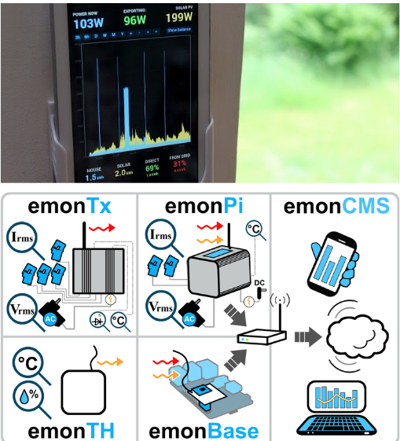

Figure 1 The EmonPi System

**Real-Time Power Monitoring, Home Automation and Sustainability**

A real-time monitoring of energy consumption is essential for energy conservation and sustainability. The project aims online real-time monitoring of energy consumption using ZPM system. The proponents of the project used the ZigBee protocol for mesh networks in home automation and Zero-Net Energy Test Home or ZNETH. (Real-time power monitoring, home automation and sustainability, 2011).

The home monitoring device and the proposed system both offer online real-time monitoring of energy. The components of the proposed system differ with the aforementioned project as the proposed system uses an Arduino-Compatible Microcontroller and the project uses the ZigBee Protocol. ZigBee uses Radio Frequency as a medium, while the proponents use Wi-Fi and HTTP as a protocol.

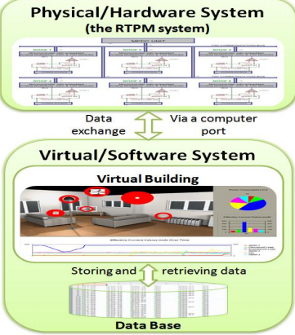

Figure 2 Home Automation Software System

#### **Smart Air Socket**

The smart socket air is a plug-in device where the user can monitor the appliances or other electrical component connected to the socket. The system is manipulated through the use of wireless connection (Wi-Fi). First, register the device to a mini server in order to generate the serial number. If it is replaced by another, do the process again. Inside of the server, the user can see the list of hours, energy and consumption of the registered device. (Smart Socket Air, 2016)

The existing device and the proposed system have the same function which is to monitor the power consumption of appliances plugged in the smart socket. The smart socket also has the feature of identifying devices and requires the device to be registered in order to be given power through the use of serial numbers. However, the smart socket can only identify one device and if it gets replaced, the user has to register the device again. The proposed system will also have the feature of registering the devices first before it can be given power, but the power socket will be able to identify multiple devices as long as it is registered in the database. The proponents may use NFC (Near Field Communication) technology or RFID for the identification of the device. Each electrical component is registered in the database and has own information listed to it. If the devices are not registered it will not be able to connect, but the user will be notified if there are unregistered devices plugged in, and the user will have the option to allow the device to get power for a limited time. The smart socket requires manually registering a certain component whenever it is replaced with another.

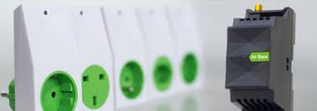

Figure 3 Smart Socket Air

#### **Smart Home Automation using Android**

The prototype gives power to control appliances with the use of Bluetooth connection (Bluetooth dongle) that ranges 10-100 meter or wireless access point. The device has five sensors in order to monitor the temperature, electrical appliances such as fans, television, computer system, etc., leak of LPG, status of windows or doors and light intensity. The prototype used electromechanical relay that is connected in each device able to switch on/off the load and a microcontroller that serves as a main server. Researchers also made an android application to ease the user in controlling the device remotely. The project also implemented a monitoring system. (Smart Home Automation, 2016)

The proposed system and the smart home automation both allow the user to control appliances and turn it on or off. The devices can also be controlled remotely. However, the proposed system is not capable of monitoring the temperature inside the home and the means of communication that will be used is through web. The proposed system will be web based so even the user is not at home, the devices can still be controlled. The smart home automation doesn’t have the function of filtering the devices that can consume power unlike the proposed system devices need to be registered in order to be given power. The proposed system has a main control panel that receives all the information regarding the devices and the energy consumption will be monitored. The power sockets will have a relay that will be used to cut the current being supplied incase the device that is plugged in is unregistered. The user will be notified if unregistered devices use the power socket and the user will have the option to allow the device to consume power.

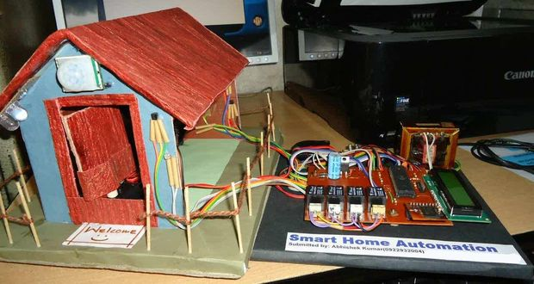

Figure 4 Smart Home Automation using Android

#### **AC Watt Meter**

The watt meter is built to measures the voltage, current, apparent power, real power and power factor. The watt meter can easily adapt the other voltage, current and frequencies, but the meter is made for 230 V, max 2.54A and 50Hz. In measuring voltage and current the watt meter establish voltage measuring circuit and current measuring circuit to monitor and to have stable output. (Prepaid Power Meter, 2008)

The device and the proposed system both measure voltage, current and power of the appliances and use a current sensor but the watt meter is only limited to measuring voltage and current. The proposed system will have the capability of monitoring the energy consumption real time and send the data to the web application. With the use of the power socket, the user will be able to control the devices that are plugged in. The user will also be notified if there are illegal connections in the power line and inform the user about the location of the illegal connection.

#### **Apple HomeKit**

HomeKit lets people securely control connected accessories in their homes using Siri or the Home app on iPhone, iPad, and Apple Watch. In iOS, the Home app also lets users manage and configure accessories. Your iOS, tvOS, or watchOS app can also integrate with HomeKit to provide a custom or branded home automation experience.

This device is limited to ios device only it allows the user to make diy(do it yourself) smart home system and it supports homekit’s compatible products you choose to start with. This said more functional one you add apple tv or an ipad that doesn’t leave home. The product is focused on controlling ios/homekit’s compatible smart devices.

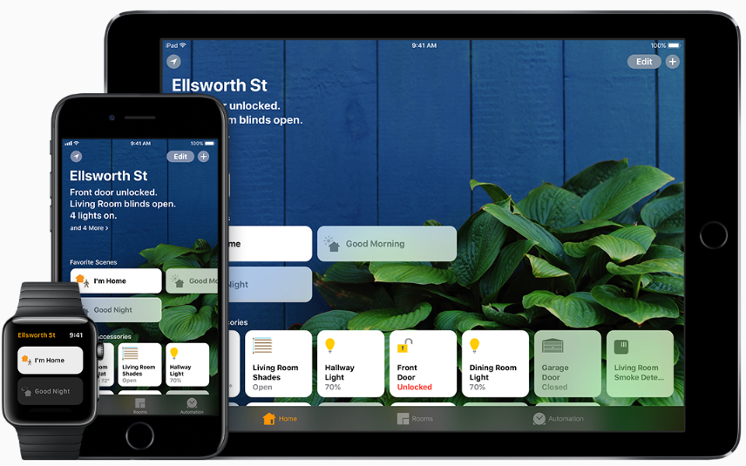

Figure 5 Apple HomeKit

### **LOCAL RELATED LITERATURE**

#### **Power Meter**

The home automation for energy monitoring meant to scan the electricity bill every month and record all the electricity consumption of all the appliances. but a device just records the total consumption of all the appliances in a month. The Power meter of General Electrical (GE) measures the kilowatt-per-hour for electricity consumption. MERALCO Company, the biggest energy or power distributor in the Philippines uses the device. Meralco has latest digital power meter that can help the users and consumers in ability to read their and easier to maintain electricity bills. (My Meralco Electric Meter is Finally Digital, 2011)

Using the device, the power consumption of every house will be measured. The proposed study will use a digital power meter that is more readable and easier than the previous power meter.

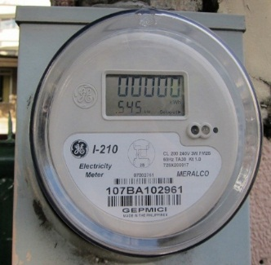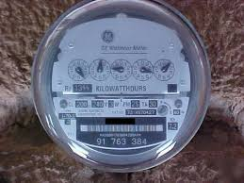

**Figure 6** Analog Power Meter **Figure 7** Digital Power Meter

# **Chapter III**

## **TECHNICAL BACKGROUND**

This chapter will further discuss in full description the development model that the proponents will use together with some of the requirements including software and hardware tools to be use in developing the system. In this chapter also discuss the process designs, flow charts and prototype user interface.

## **Methodology**

The software development life cycle (SDLC) is a framework defining tasks performed at each step in the software development process. SDLC is a structure followed by a development team within the software organization. It consists of a detailed plan describing how to develop, maintain and replace specific software. The life cycle defines a methodology for improving the quality of software and the overall development process.

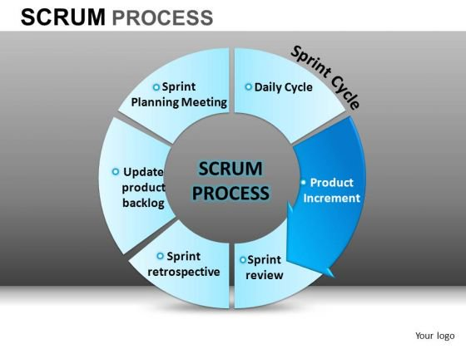

**Figure 8** Scrum Development Diagram

In order to manage the project, the proponents used Scrum as a project management methodology.Scrum framework allows you to implement Agile development methodology. Unlike the waterfall software development life cycle, the distinctive feature of Scrum is the iterative process of developing.

Development divides into several phases. Each of them results into a ready-to-use product. At the end of each step (called sprint in Scrum terminology) a ready product is delivered to a customer. Customer’s feedback helps reveal possible problems or change the initial plan, if needed. Planning the development period, the systems was on a timeline divided into sprints with the first sprints focusing on the most important parts of the functionality of the system. Since the proposed project was defined in the documentation, the proponents figured to do the system modularly by dividing the tasks into sprints and by doing so makes debugging faster and more efficient.

**Product Backlog Creation Phase**

Product backlog is a list that consists of features that should be implemented during the development process. It’s ordered by priority and its every item is called a User story. In this case, user will make use of the Gantt chart as basis of the backlogs to be created. Each entry in the Gantt chart will be converted into backlogs. After the product backlog creation is finished you can move to the next step – sprint planning.

**Sprint Planning and Sprint Backlog Creation Phase**

Firstly, the proponents will determine what the sprint’s duration will be. In this case the proponents will make use of the Gantt chart’s timeline as a guide. What’s more important at this phase is the cooperation of all the proponents and other important people especially expert advisers.

After that, the scrum team will select the most important user stories from the product backlog. Then the proponents will decide how they will solve this or that task. The Sprint backlog should be created next. It consists of user stories that will be completed during the current sprint. The amount of these stories depends on their duration in story points assigned to each story during evaluation stage. The team should be capable to finish all these stories on time.

**Working on the Sprint. Scrum Meetings Phase**

After actual user stories for the current phase are chosen, the website development process begins.

To track the current working process, a task board will be used. There are usually big cards with the names of particular user stories and a bundle of little sticky notes with a description of single tasks which are needed for implementation of this or that story.

These cards are arranged according to their importance. When work on a task has been started, the corresponding sticker is moved from the “To do” field to the “In progress” one. When work is completed, the sticker can be moved to the “Testing” field and after the task is successfully tested, the sticker goes to the “Done” field.

**Testing and Product Demonstration Phase**

Since the ideal result of every sprint is a working product, the [full life-cycle testing](https://xbsoftware.com/qa-software-testing/full-qa-cycle/) process is very important. The result of every sprint is product demonstration. The Scrum team will create a review and demonstrate the results of their work. Afterwards, the proponents along with the adviser will take a decision about further project changes.

**Retrospective and Next Sprint Planning Phase**

Retrospective’s main aim is to discuss the results and determine the ways how to improve the development process on the next step. The team should conclude what went well during the working process and what can be done better during the future iteration. When the ways of improvement are defined, the team can concentrate on the next sprint planning.

### **Requirements Analysis and Documentation**

This section further discusses the product in context and give description to its expected finished output. The requirements include the tools that needed to accomplish the said device.

#### **Requirements Documentation**

##### **Technical Requirements**

1. **Account Registration** – The user should be able to register an account to access the system.
2. **Appliance Registration** – The user should be able to register an appliance on the system’s database.
3. **Appliance Monitoring** – The user should be able to monitor currently plugged registered Appliances.
4. **In-app Notifications** – The user should be notified if an unregistered appliance(s) is/are plugged into the socket.
5. **Power Sockets Control** – The user should also be able to control their behavior such as turning them on and off and limit their consumption.

##### **Software and Hardware Requirements**

**Table 1**

**Minimum Software Requirements**

|  |  |
| --- | --- |
| Software | Version |
| Google Chrome | 67.0.3396 and later |
| Mozilla Firefox | 52.0 and later |
| Operating System | Android Lollipop and later versions, iOS 8 or later versions |

Table 1 shows all the minimum software requirements in order for the users to utilize the Proposed System. Google Chrome and Mozilla Firefox are used to access the website of the proposed system. And the Operating System should be running Android Lollipop or later, iOS 8 or later.

**Table 2**

**Minimum Hardware Requirements**

|  |  |
| --- | --- |
| Hardware | Specification |
| Desktop/Laptop | Intel Pentium 4 processor or later  2GB of RAM or higher |
| Mobile Phone | Android:  At least 1 GB of RAM  4GB internal Storage  iOS:  iPhone 4s and later |
| DD-WRT Router | Has wireless capability |
| Raspberry Pi | Version B+ or later |

Table 2 shows the minimum hardware requirement of the proposed system for it to run properly. DD-WRT is a Linux-based firmware project developed to enhance the performance and features of wireless Internet routers. This open-source firmware upgrade is developed for specific router models and used as a replacement for the inconsistent stock firmware. Modifying a router to DD-WRT lifts restrictions built in to the default firmware, providing advanced capabilities to make your Internet and Home Network more controllable and versatile.

### **Design of Software, Systems, Product, and Processes**

The proponents proposed a system that has three major components that varied distinctly in function. The proponents named each components distinctly in order to differentiate the functions of the components in the architecture of the system.

Considering the theories of the aforementioned literatures and principles of digital circuits, logic design, and components available on the market, the proponents are able to solve the problems that have been mentioned by applying the principles of the chosen reference of the proponents. The local references proved to be very useful in determining what methods were available for the proponents to utilize in their projects.

#### **Entity Relationship Diagram**

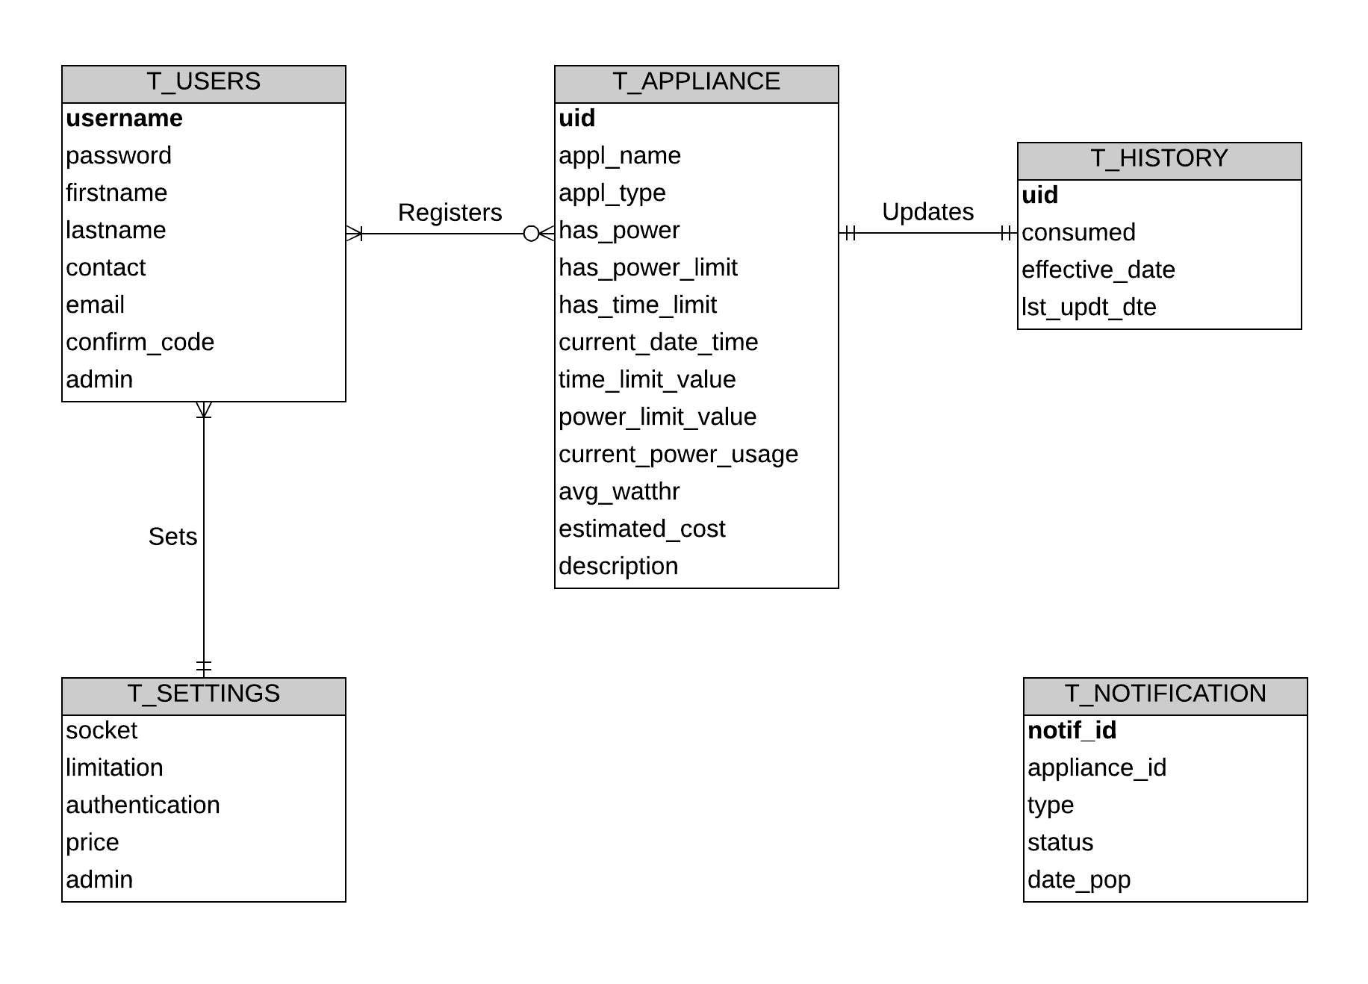

Figure 9 Entity Relationship Diagram of Appliance Registration and Monitoring

As shown in Figure 9 are constraints that will be considered in building and accomplishing the product. First, each T_USER can optionally register T_APPLIANCE, inversely T_APPLIANCE can be optionally registered by each T_USER. Next, each T_APPLIANCE updates its T_HISTORY and inversely, T_HISTORY is updated by the T_APPLIANCE. Lastly, each T_USER can set T_SETTINGS and inversely, T_SETTINGS can be set by each T_USER. note that T_NOTIFICATION has no connection to other entities because it is only used for the Notification purposes of the proposed system whenever an appliance is plugged in.

#### **Context Diagram**

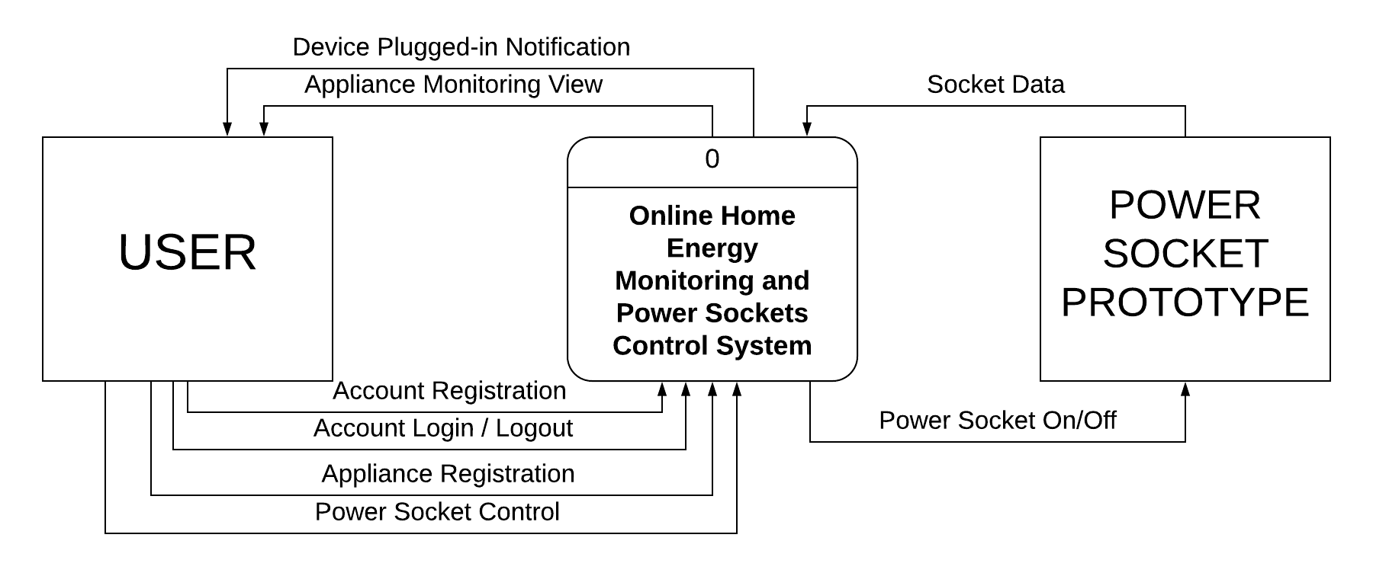

**Figure 10** Context Diagram of Online Home Energy Monitoring and Power Sockets Control

As shown in figure 10, the USER can register an account and the ability to login and logout. While logged in, the USER can register an appliance to the database and has control on the POWER SOCKET UNIT and can monitor the plugged in device consumption and can receive plugged in device notifications through the use of the “Online Home Energy Monitoring and Power Sockets Control System.

#### **Data Flow Diagram**

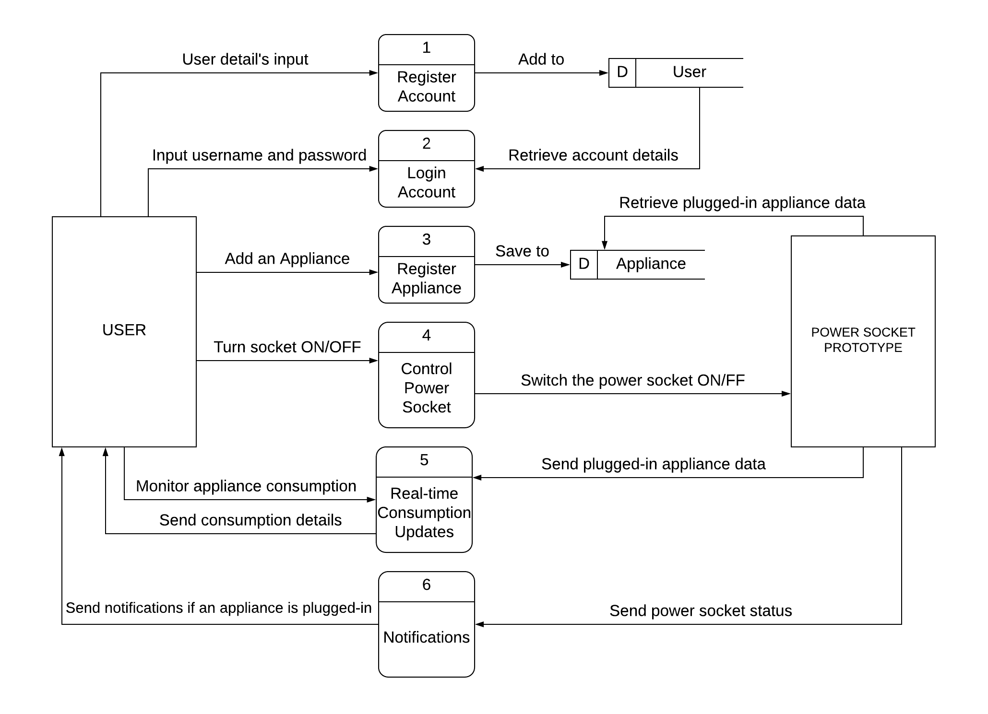

**Figure 11** Dataflow Diagram of Online Home Energy Monitoring and Power Sockets Control System

As shown in figure 11, the flow of data are as follows: The user must register for an account to save it on the database. Then, the user must be logged in in order to register an appliance. After registering the appliance, the user now can monitor its consumption updates and has control of the sockets, consumption reports are then generated so that the user can view it graphically. The application will also send notifications to the user.

#### **Block Diagram of the System**

The System is divided into three main components namely the Power Socket, the Main Control Panel, and the Access Device. Out of the three main components, two of the mentioned components were assembled, built, and programmed by the proponents, the Main Control Panel and the Power Socket.

The Main Control Panel

The Main Control Panel is the Central Processing Unit of the System. As you can see in Figure 12, the Main Control Panel is responsible for the computation, comparison, and decision-making processes of the system and contains the Master Processor that makes deduction of the decisions based on the input and the variables set by the proponents.



Figure 12 Block Diagram of the Main Control Panel

The Power Socket

The Power Sockets, as seen on Figure 13 are the receptacles that are responsible for providing power to the appliances, The Power Socket contains identifiers and sensor circuits that determines or recognizes appliances to cross check to the database of the Main Control Panel. The Power Socket also contains the sensor that measures the incoming current from the Main Control Panel Power lines. The current measured is essential for the specific objectives of the study, the detection of unauthorized connection as well as the measuring the total power consumption of the user.

The Identification module is responsible for recognizing devices by an identification tag, if available. The relay module is responsible for switching the 220V power line on or off towards the receptacle of the Power Socket. Lastly, the Wi-Fi Module is responsible for transmitting and receiving data towards and from the Main Control Panel.

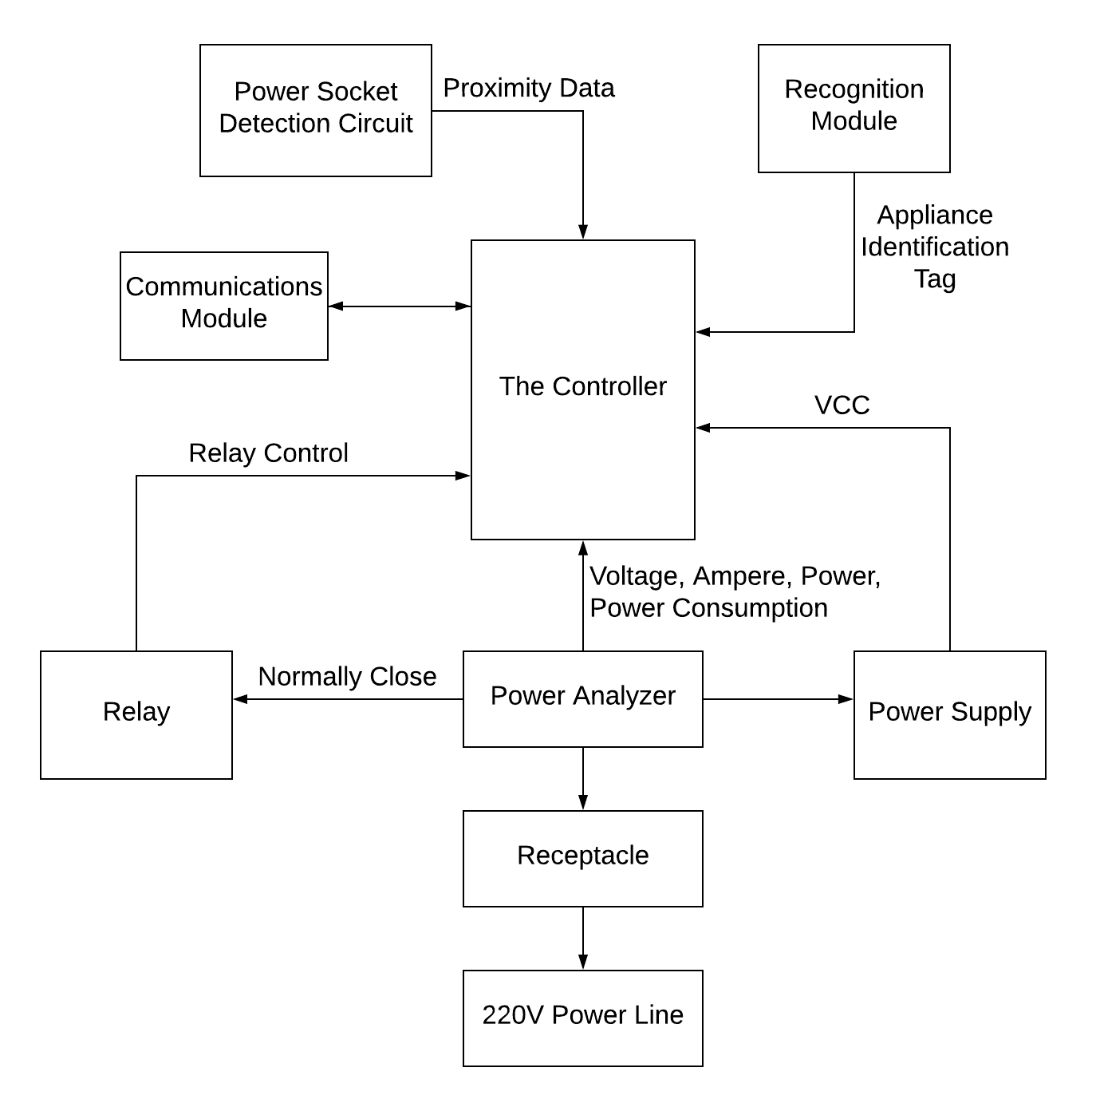

Figure 13 Block Diagram of the Power Socket

The Network Connection of the Components

The System requires an external common access point as shown in figure 14 in order to function. The access point is a wireless router that the Power Sockets, Main Control Panel, and the Access Device connects in order to communicate with each other.

The Wireless Access Point is required for the operation of the System. While the operation is possible by configuring the Controller of the Main Control Panel and Communications module as an Access Point, the proponents decided against. The reasoning behind the decision is that the user needs to change Access Points whenever the user wants to check the operation of the system and that the information available on the system is not easily available on the internet if configured as an access point. Making the System connect into an Internet connected wireless access point makes the information of the System available with fewer steps to be done by the user. Although, the proponents emphasize that Internet connectivity is not a requirement for the system to function and that the system is not optimized for security for doing so.

network topology

Figure 14 Representation of the Network Setup

The Security of the Wireless access point is out of the concern of the proponents as the security is dependent on the security policy, the router manufacturer and the firmware embedded in the wireless router.

#### **The Overview Block Diagram of the System**

**Figure 15** Overview Block Diagram

Figure 15 shows that the communication of the device to the power socket and control panel uses wireless communication, which in this case is Wi-Fi, and a wireless access point as the mediator between the three. The data will be sent to the server and in turn the wireless access point reads the server and communicates the message to the power socket and main control panel.

#### **Systems Flowchart**

The Proponents designed the system to accept appliances with or without an identifier tag. The Systems flowchart is designed to be modular with processes that can be properly defined using programming functions.

The logic of the Power Socket is illustrated in Figure 16 and shows the complete Systems Flowchart of the Power Socket System. With the Arithmetic Computations done in the server, the power socket could be powered by a Microcontroller with very little memory.

The logic of the server is more complicated than the Power Socket as it includes most of the Arithmetic Operations, Processing of Data, Notifications, Web Hosting, and many more. This requires a more powerful controller and a higher complexity of components to use. Luckily, there is a solution in the market that combines the power of a small computer with the flexibility of input and output of a microcontroller, the Raspberry Pi.

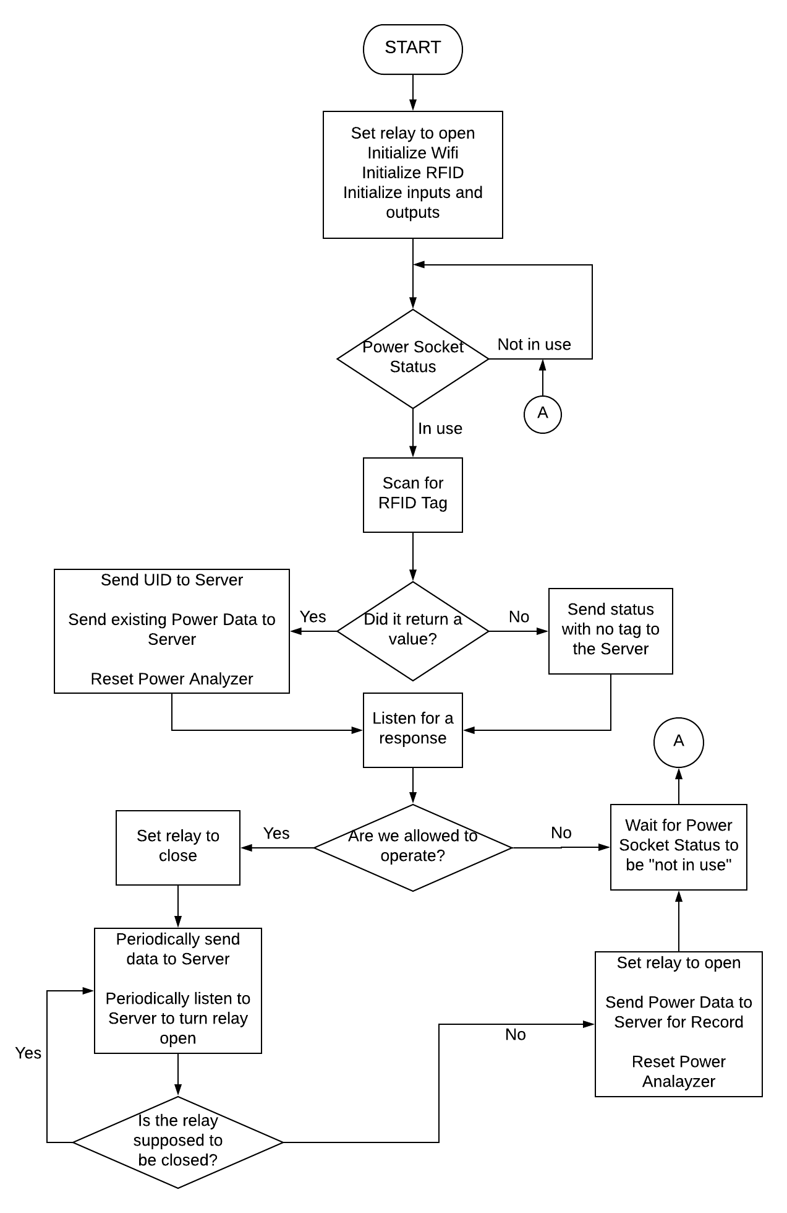

Figure 16 Power Socket Operation

One of the vital functions in the system is to compute the Total Wattage of the System. In that regards, the proponents. The proponents have chosen a component that transmits watt hour data onto serial which is done independently with a dedicated hardware. Therefore, less processing needs to be done by the Power Socket.



Figure 17 Simplified Operation of the Main Control Panel Server

The basic function of a server can be summarized with a simple flowchart as represented by Figure 17. However, the complication starts when one expands on defining the Web Services. In the proposed project, the Web Services are the PHP scripts and Web Applications that allow the operation of the system to function properly.

One of the functions of the Server is determining the operational status of a relay using the RFID tag that may or may not be registered in the appliance. The operation of the function is illustrated on Figure 18.



Figure 18 Server operation determining relay status

The Mobile Application Home page is represented by Figure 19 and User Login will serve as the Application’s homepage. The user also have the option to create an account to be able to log into the Application. After logging in, the user will proceed to the system dashboard and will have the privilege to choose from a range of menu.



Figure 19 Application Home Page and Login Flowchart

For starters, the User Registration Page, as shown in Figure 20, will be the first page to look up to in order to create a new account. The user will fill up a form and each field will be validated before proceeding to the next stage. After validation, the system will send a verification message along with the verification code to verify whether the user is a valid user and not just a spammer or a fake one. A verification form will also be prepared for the user to enter the verification code. After verifying, the account credentials will be saved into the database and a notification of completion will be sent.



Figure 20 Application User Registration Page Flowchart

As shown in Figure 21, different menu selection will be available after the user logged in. Each menu selection will send a HTTP AJAX request to the server. After the Request is received by the server, the server will then test connection until the connection state is ready and then it will send the corresponding html page.



Figure 21 Application Menu Flowchart

In Figure 22, appliance registration process is described and illustrated. User will fill out the form with data and send validation. If the inputted information are valid, the application will be saved as registered application on the database otherwise, a notification of failure will be sent to the user.



Figure 22 Appliance Registration Flowchart

In Figure 23, the general settings processes are represented in a flowchart. Every change in the Settings will affect the whole system including, appliance authentication, power socket status and consumption limit.



Figure 23 Application General Settings Flowchart

### **Development and Testing**

In order to achieve the proponents’ idea of the project, testing the hardware and its accuracy is required. Tests have been devised in order to see the accuracy and reliability of the system. These tests challenge the different modules of the system to examine whether the project is coursing its way towards the product that the proponents have planned.

**Power socket status check.** This test is devised to check the whether the identification logic programmed in the Power Socket is functionally correct. The relay is expected to turn on when a Registered RFID Tag is scanned and should not turn on when an unregistered RFID Tag is scanned.

**Appliance Identification.** This test verifies the ability of the Power Socket to send UID data to the Main Control Panel Server and the Main Control Panel’s ability to cross check data in the database. The Information for the appliance should display in the PHP webpage. A pre-requisite for this test is that the appliance tags to be tested should be registered to the database of the server as well as the Main Control Panel and the Power Socket is linked locally by a Wireless Router.

**Power Analyzer Accuracy.** This test is devised to check the accuracy reading of the AC Power Analyzers employed to read the power of plugged in appliance. The proponents purchased a dedicated AC Digital Wattmeter for the testing and used it as a basis for the AC Power Analyzers of the Power Socket. A 90% minimum target accuracy is needed for the test to be deemed successful.

**Power Socket Usage Recognition**. This test takes note of the Power Socket Usage Circuit’s performance using different kinds of plugs available in the market. This test is essential for the proponents to determine the Voltage value of the proximity sensor that is needed for the Power Socket to determine whether there is a plugged-in appliance or not.

**Notification and Database Logic.** The objective of the test is to notify the user when an appliance has been plugged in and correspond with the appropriate status of the plugged-in appliance. The notification should pop-up when an appliance is plugged in.

**RFID Distance Test.** This test is devised to determine whether it is possible for the RFID to be positioned behind the power socket. Measuring the distance in centimeters will determine the maximum distance the RFID could successfully read the RFID tags.

**Proximity Sensor and Identification Test.** The function of the proximity sensor is to determine whether there is an appliance plugged in on the Power Socket. The power socket should scan for an RFID Tag when the voltage of the proximity sensor reaches an appropriate level. This test is devised to determine whether the proximity sensor is reading the status of the power socket and power plug correctly.

### **Description of the Prototype**

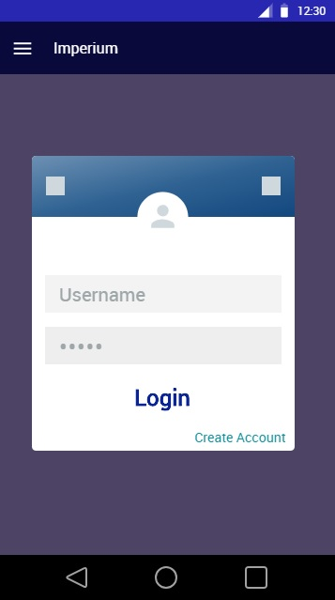

**Figure 24** Login Interface

As shown in Figure 24 the Login Interface presents the Login form where the user input their username and password to access the system.

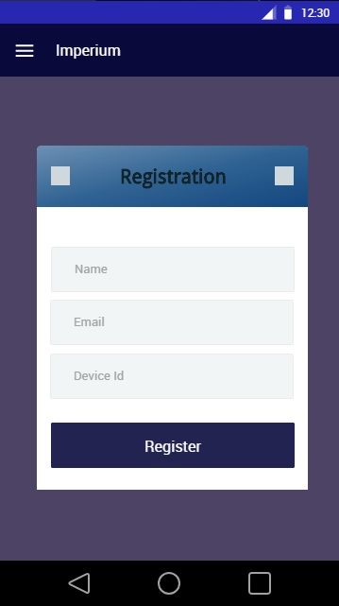

**Figure 25** Registration Interface

As shown in Figure 25 the Registration Interface allows the user to create an account to be use when logging into the application.

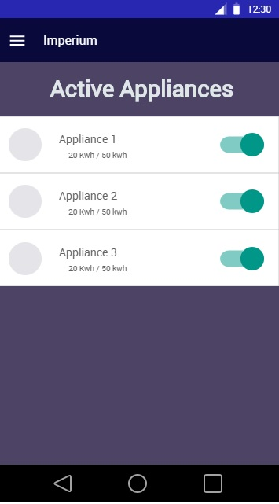

**Figure 26** Dashboard/ Active Devices Interface

As shown in Figure 26 is the Dashboard or Homepage of the Application where the user can view active/ plugged devices and turn them on and off.

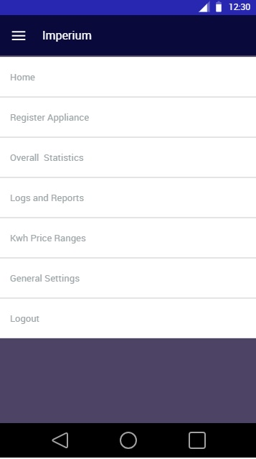

**Figure 27** Main Menu

As shown in Figure 27 the Main Menu allows the user to navigate through the different parts of the system after logging in.

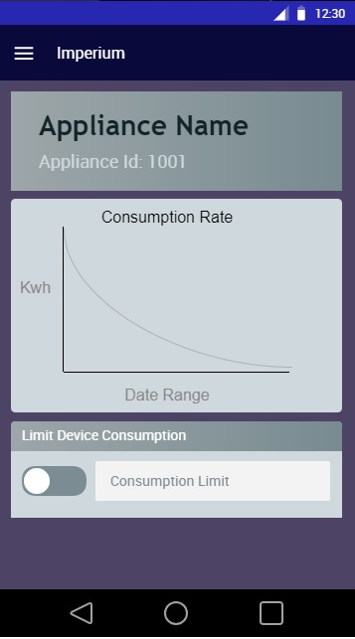

**Figure 28** Appliance Description and Status

As shown in Figure 28 the details of the selected appliance is presented including its consumption and limit.

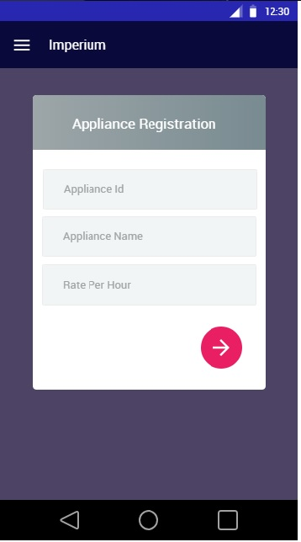

**Figure 29** Appliance Registration Interface

As shown in Figure 29 Appliance Registration Interface allows the logged user to add or register another appliance.

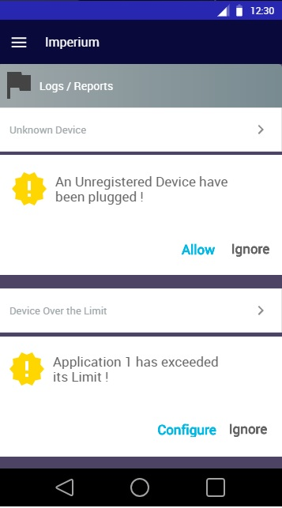

**Figure 30** Logs and Reports Interface

As shown in Figure 30 the Logs and Reports Interface shows the user whenever an unauthorized device is plugged in. Also, user will be notified when a device exceed its power limit.

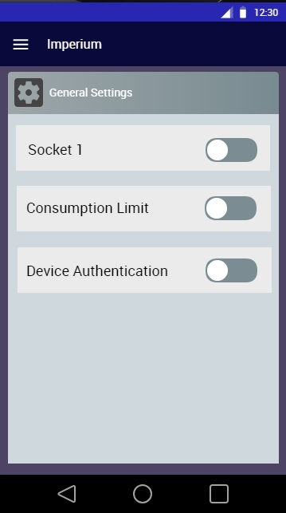

**Figure 31** General Settings Interface

As shown in Figure 31, in the General Settings Interface you can turn on/off the sockets, consumption limit and device authentication.

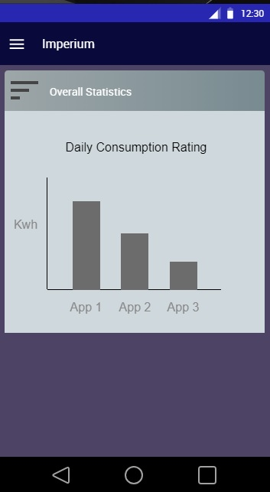

**Figure 32** Overall Statistics Interface

As shown in Figure 32 Check and Statistics Interface allows the user to check and compare the consumption on the past results.

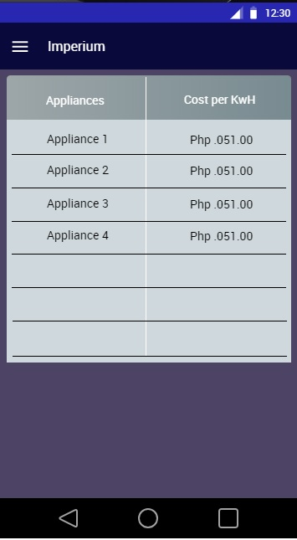

**Figure 33** Kwh Price Ranges Table

As shown in Figure 33 is the list of Price per KwH of each devices and applications.

# **Chapter IV**

## **RESULTS AND DISCUSSIONS**

This chapter puts the project in context and includes a discussion of the answer to specific objectives stated in the previous chapter.

## **Features of the Developed Software**

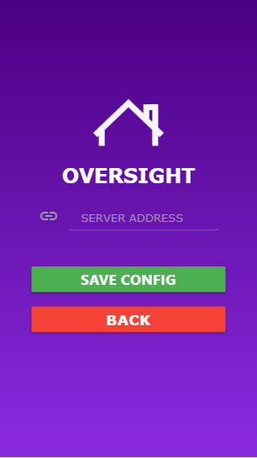

**Figure 34** Server Address Configuration

Figure 34 shows the Server Address Configuration Interface.

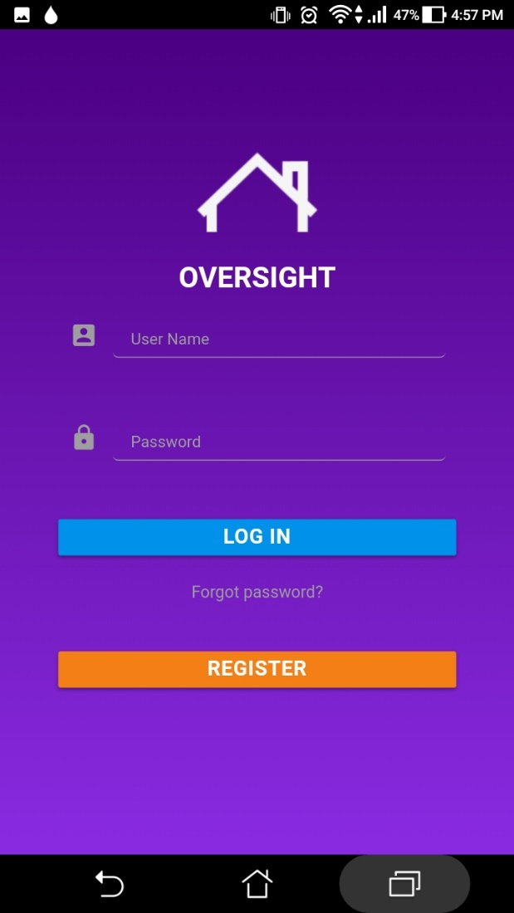

**Figure 35** Login Interface

As shown in figure 35, this is where the user login, register for an account or retrieve account in case the user forgets his/her login credentials.

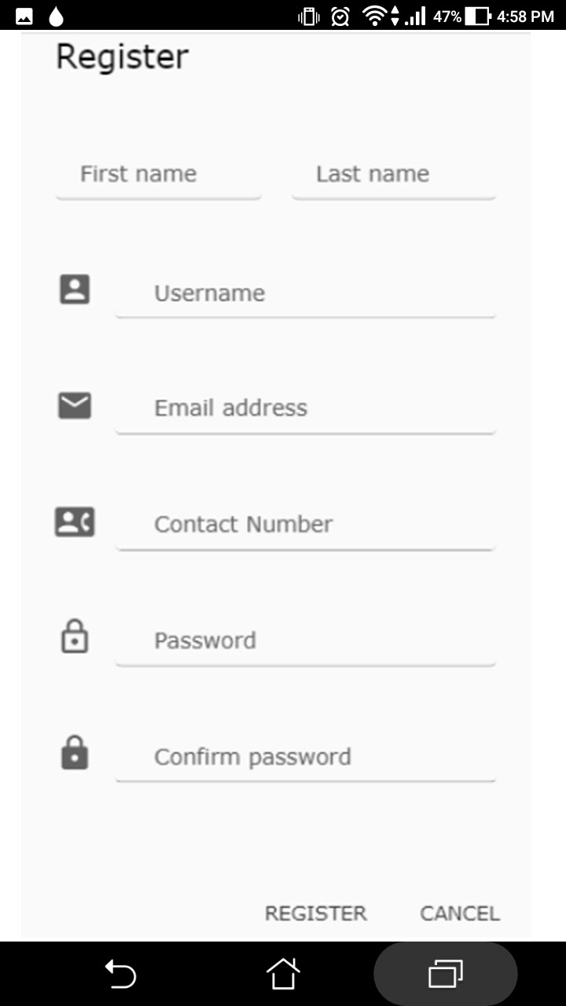

**Figure 36** Account Registration Interface

Figure 36 shows the Registration form for the Users.

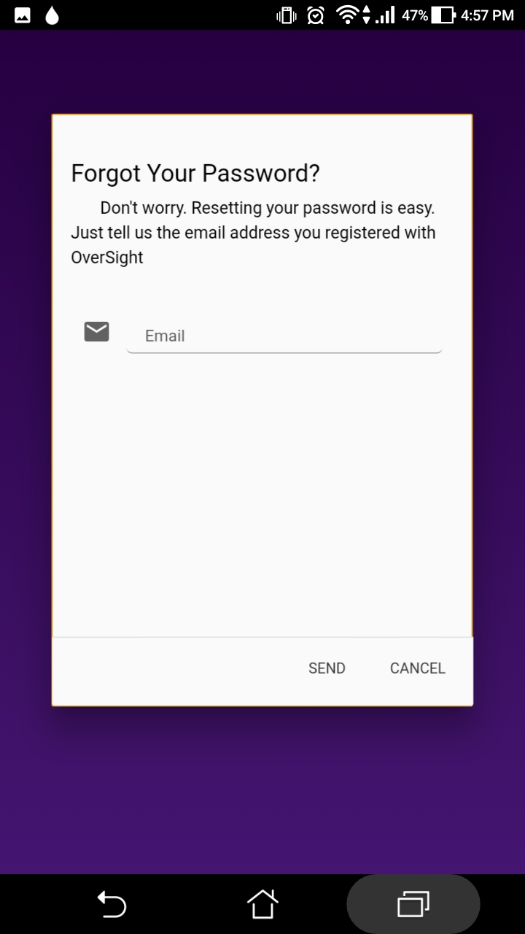

**Figure 37** Forgot Password Form

Figure 37 Asks the User to input the email addressed that is used to register the account in order for it to send a password reset email.

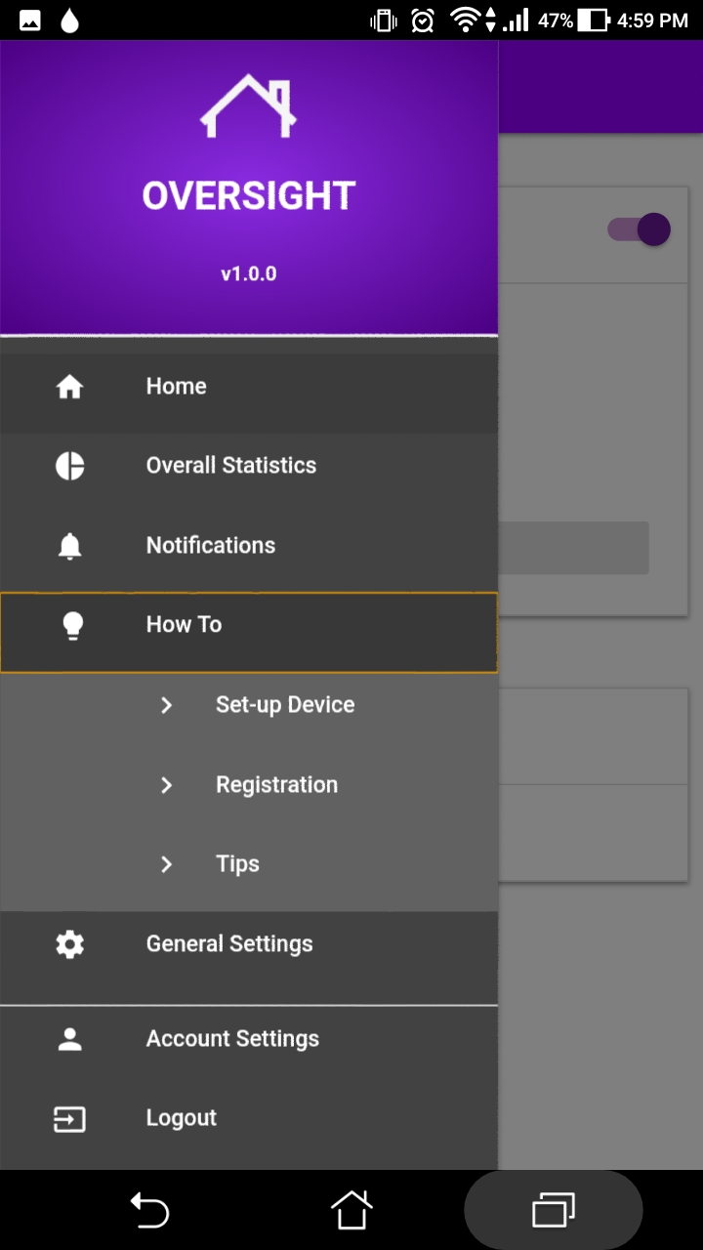

**Figure 38** Main Menu

Figure 38 shows all the features of the developed system

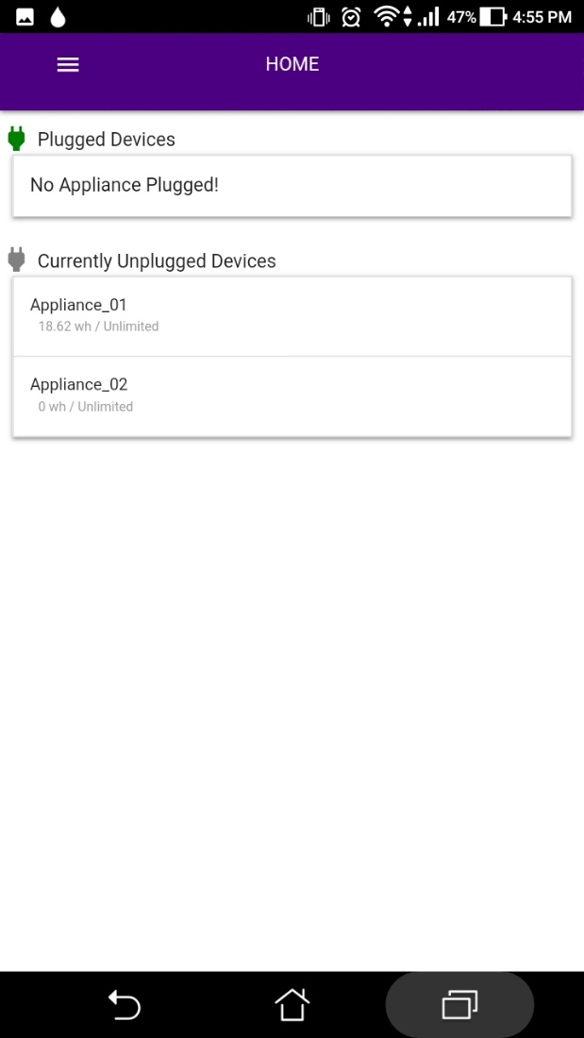

**Figure 39** Home Interface

Figure 39 shows the Home Screen of the Developed System, it lets the user see the currently plugged appliance and the registered appliances that are not plugged in at the moment.

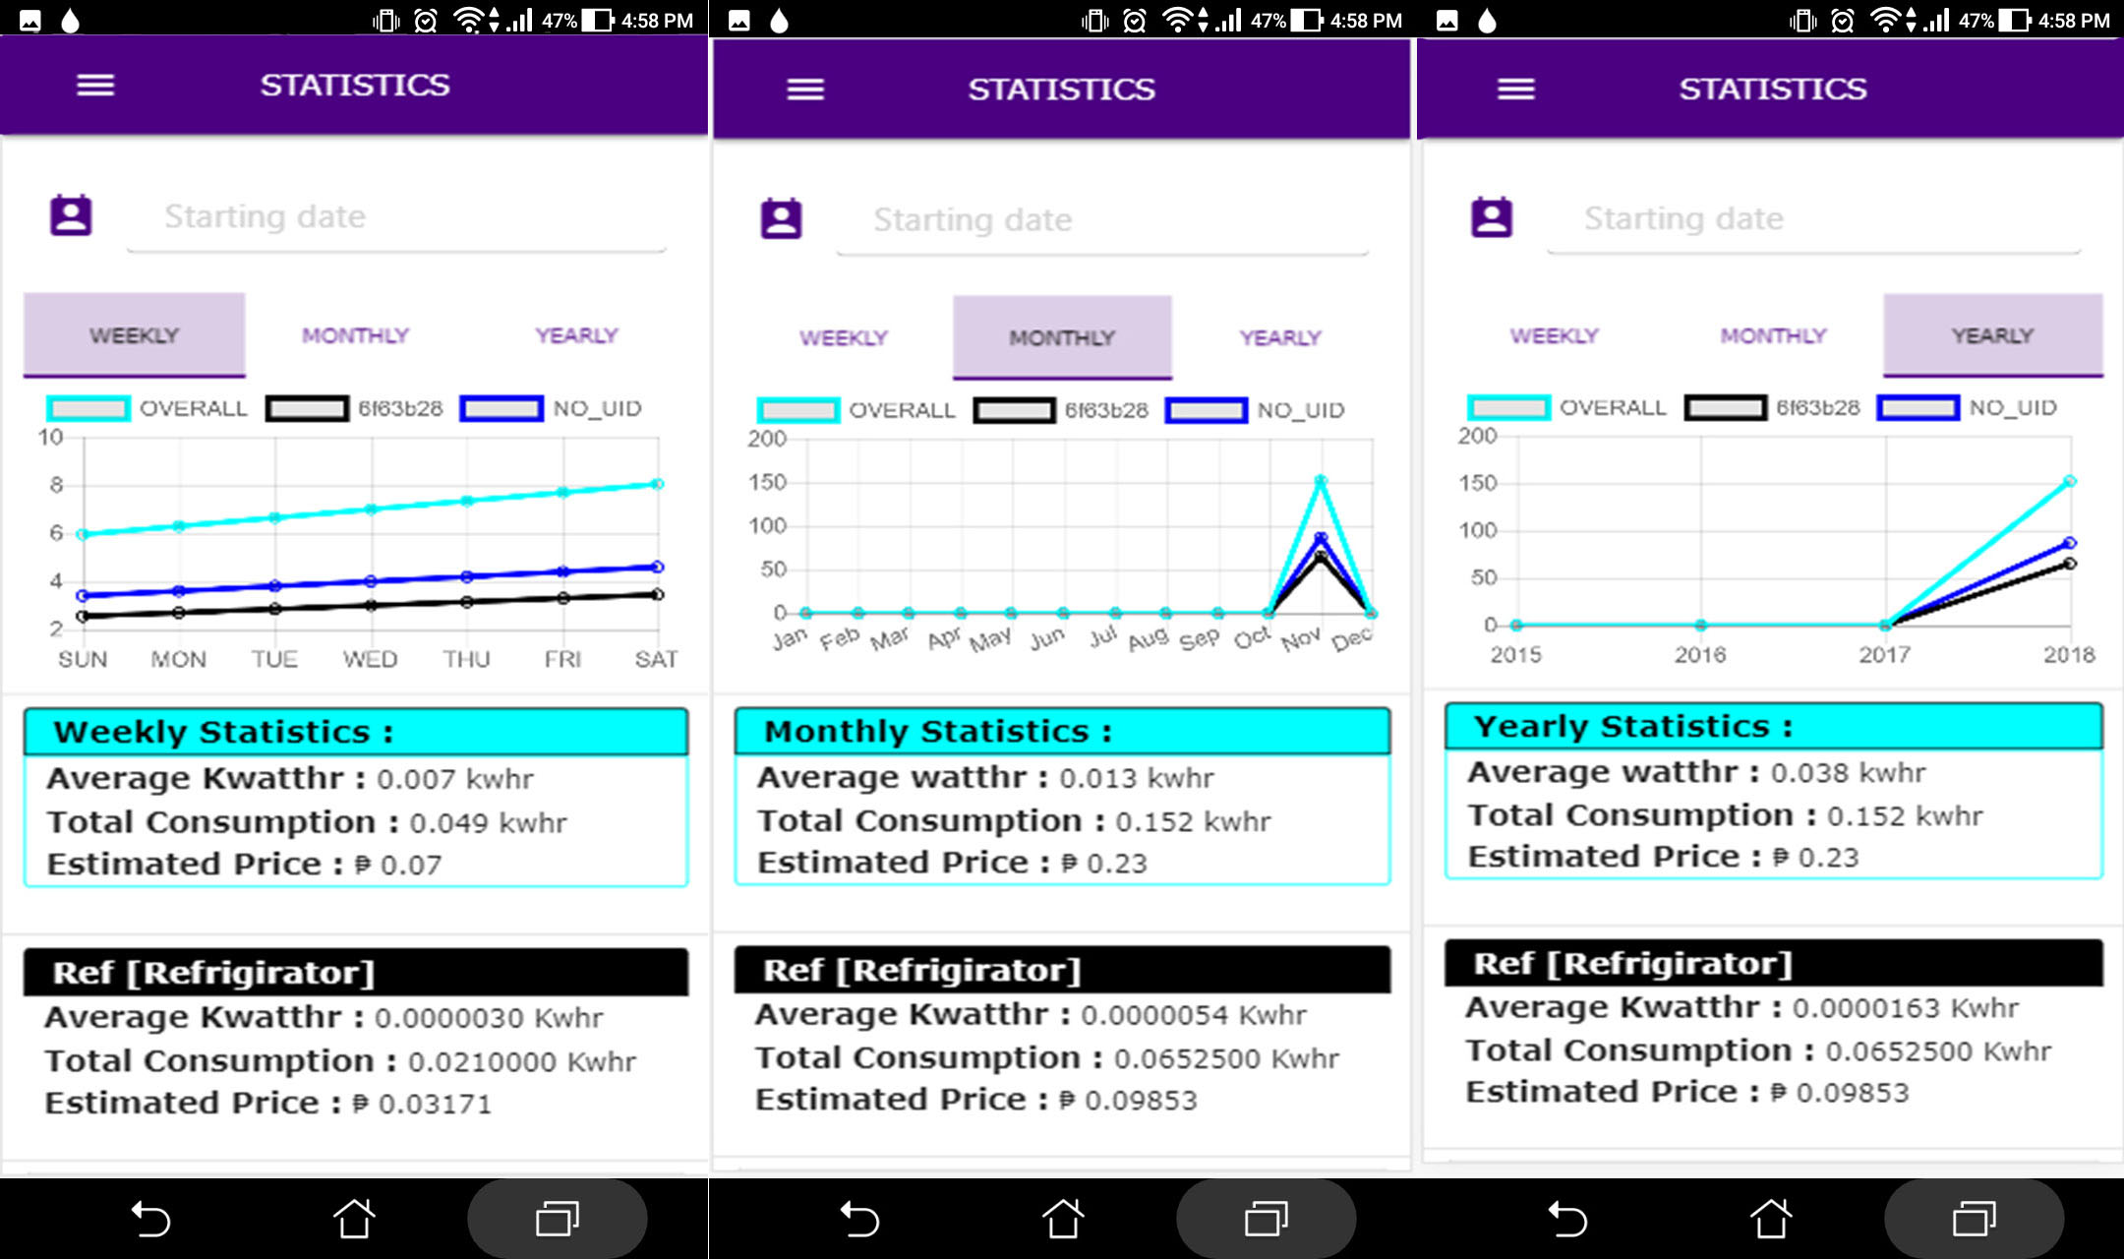

**Figure 40** Overall Statistics Interface

Figure 40 shows the consumption details of each appliance that are plugged-in and the weekly, monthly and yearly consumption of all the appliance that are registered on the developed system

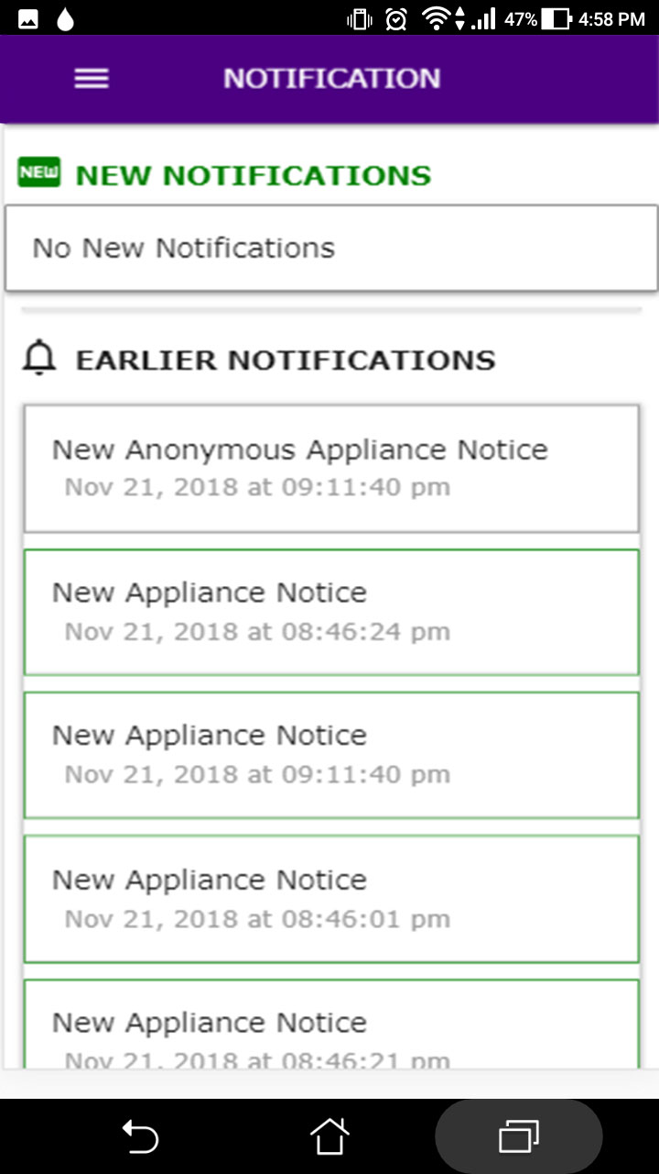

**Figure 41** Notifications Interface

Figure 41 shows the notification whenever an appliance is plugged-in.

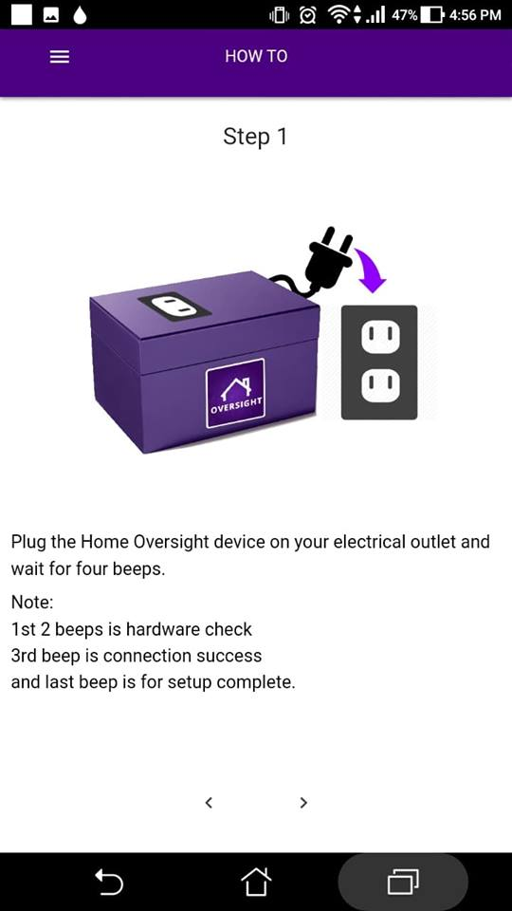

**Figure 42** Device Setup Instruction Interface

Figure 42 shows the instruction on how to setup the power socket unit

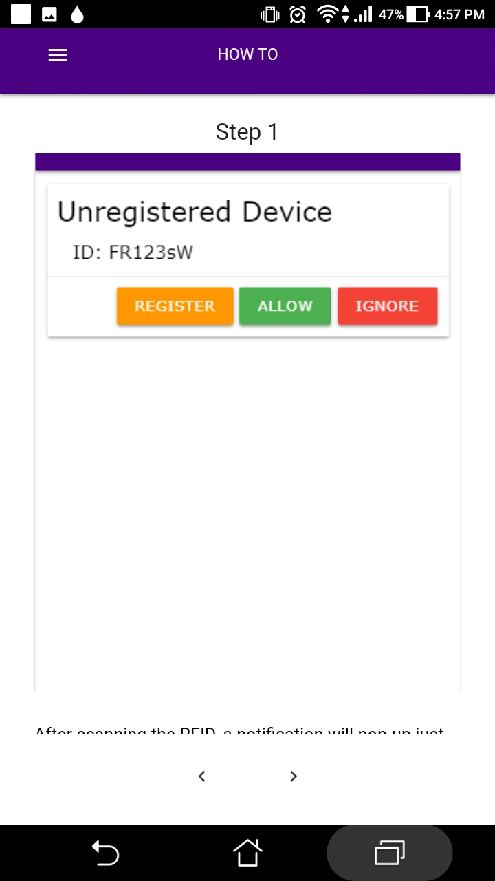

**Figure 43** Appliance Registration Tutorial Interface

Figure 43 shows the step-by-step tutorial on how to register an Appliance.

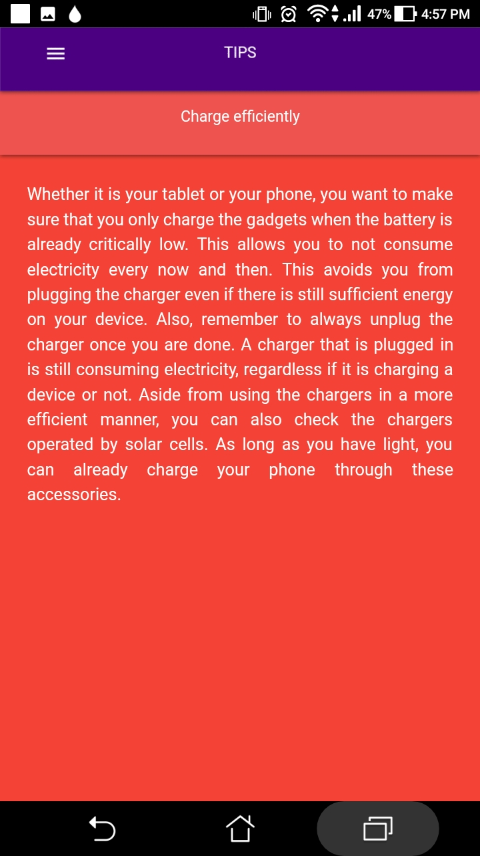

**Figure 44** Electricity Conservation Tips Interface

Figure 44 shows some tips on how to conserve electricity for the benefit of the consumers.

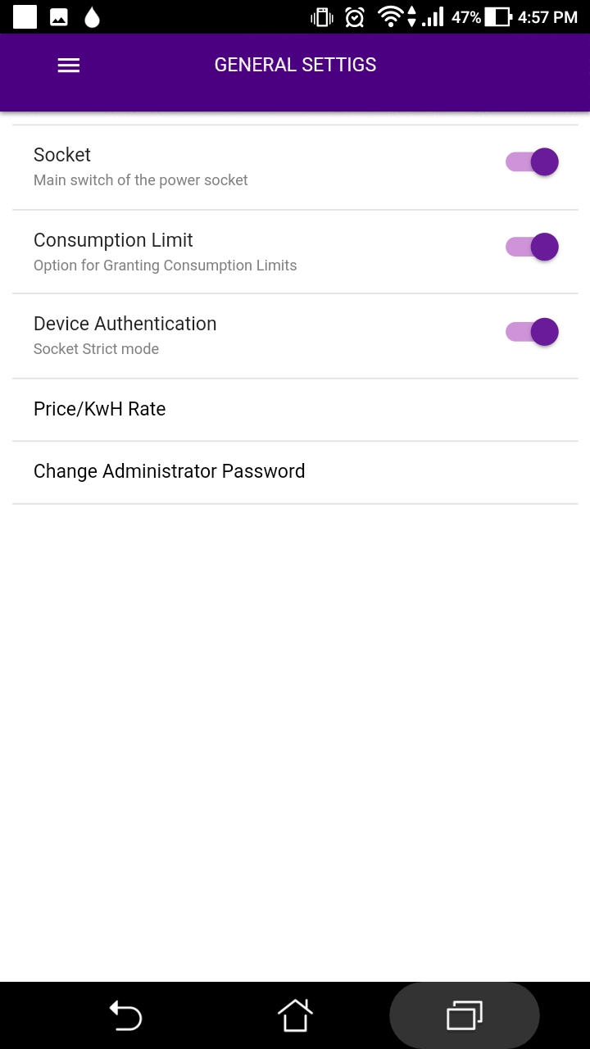

**Figure 45** General Settings Interface

Figure 45 shows the general settings for the power socket unit and the price per Kilowatt Hour rate. The Socket toggle button lets the user to turn ON/OFF the main power socket unit switch which means that it will not supply electricity to the plugged in device if there is any. Consumption Limit toggle button is used if the user wants to enable or disable the consumption limit of the power socket unit. The Device Authentication toggle button if enabled, it will only supply electricity to those appliance that are registered.

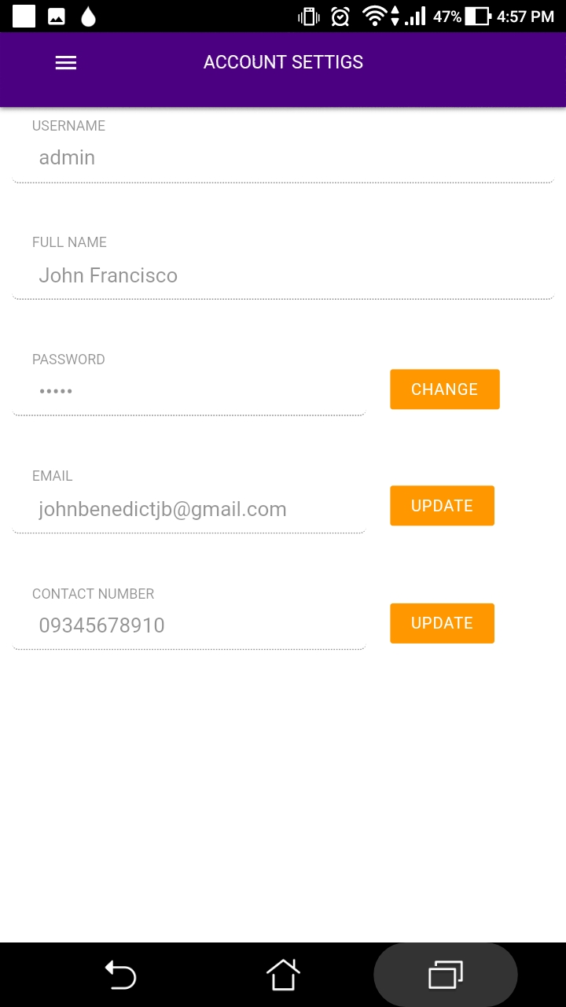

**Figure 46** Account Settings Interface

Figure 46 contains the user’s account credentials which can be edited or updated if the user wants it to be changed.

## **Features of the Developed Hardware Prototype**

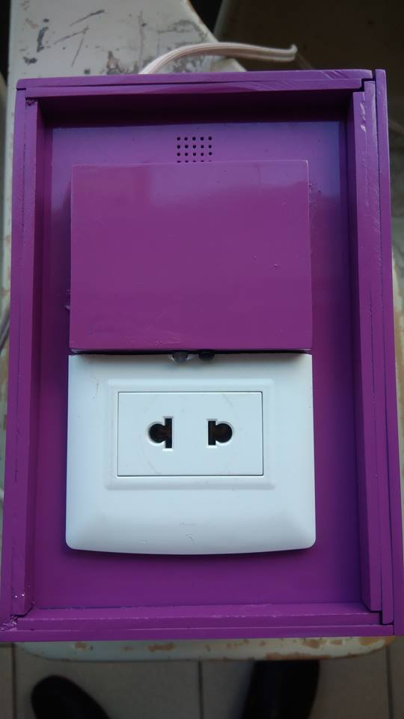

**Figure 47** RFID Recognition

Figure 47 showcases the RFID Recognition Feature of the prototype. It works by placing the RFID card/tag above the surface encircled on the photo.



**Figure 48** Appliance Plugging Detection

Figure 48 show the location of the IR Sensor (encircled in red) that detects power plugs whenever they are plugged in the power socket unit.



**Figure 49** Buzzer

Figure 49 shows the location of the buzzer, it is used for alerts.

## **Implementation of the Agile SCRUM Software Development Model**

|  |  |  |  |  |  |
| --- | --- | --- | --- | --- | --- |
| **Activities** | **Problem** | **Mitigation** | **Change Management Plan** | **Status** | **Date** |
| **Planning** |  |  |  |  | **62 days** |
| Develop Project Plan | --Communication | -Online meetings |  | Completed | 05/21/2018 – 06/10/2018 |
| Analyzing Project Cost |  |  |  | Completed | 05/21/2018 – 05/27/2018 |
| Create Project Scope |  |  |  | Completed | 05/21/2018 – 05/27/2018 |
| Contract Making |  |  |  | Completed | 05/27/2018 –  05/28/2018 |
| Expert Consultation |  |  |  | Completed | 05/28/2018 – 07/22/2018 |
| Milestone: Project Plan Approval |  |  |  | Completed | 05/28/2018 |

**Project Planning**

**Table 3:** The Planning Phase

Problem 1:

The Project Manager is responsible for ensuring that the team is doing their tasks. Difficulty in task updates are experienced due to the lack of meetings on the dates of 5/27/2018, 05/30/2018, and 06/02/2018 respectively.

Mitigation:

The Project Manager decided to schedule online meetings on the said dates. The Team used Facebook’s social media platform as a tool in order to perform online meetings.

**Project Execution**

|  |  |  |  |  |  |
| --- | --- | --- | --- | --- | --- |
| **Activities** | **Problem** | **Mitigation** | **Change Management Plan** | **Status** | **Date** |
| **Execution** |  |  |  |  | **154 days** |
| Project Team Meeting | - |  |  | Completed | 06/04/18-  06/04/18 |
| Develop Project Schematic Design for Power Main Panel |  |  |  | Completed | 06/04/18-  06/10/18 |
| Develop Project Schematic Design for Power Socket |  |  |  | Completed | 06/11/18-  06/17/18 |
| Develop Mobile Application UI | UI Revision | Change UI into Material Theme |  | Completed | 06/18/18-  10/27/18 |
| Programming Stage | Bugs and Errors | Debugging |  | Completed | 06/11/18-  11/04/18 |
| Purchase of Hardware Parts |  |  |  | Completed | 07/04/18-  07/09/18 |
| Assembling of the Hardware Prototype | Power Analyzer exploded | Purchased new Power Analyzer |  | Completed | 07/16/18-  08/06/18 |

**Table 4:** The Project Execution Phase

Problem 1:

The Thesis Adviser suggested to revise the Mobile Application User Interface as it does not meet the quality of a good user interface.

Mitigation:

The Team’s frontend developer came up with a new user interface based on “Material Theme”

Problem 2:

The Team’s backend developer had a hard time in the programming phase because of the bugs and errors that are encountered while coding the Developed System.

Mitigation:

The Project Manager decided to have a team’s overnight stay in order to brainstorm and come up a solution to the existing bugs and errors.

Problem 3:

The hardware prototype had a short circuit after connecting it to the Computer which caused the power analyzer of the prototype to break.

Mitigation:

Bought another brand new power analyzer as soon as possible to continue the programming on the hardware prototype.

**Project Monitoring**

|  |  |  |  |  |  |
| --- | --- | --- | --- | --- | --- |
| **Activities** | **Problem** | **Mitigation** | **Change Management Plan** | **Status** | **Date** |
| **Monitoring** |  |  |  |  | **62 days** |
| Maintenance of Hardware | - |  |  | Completed | 08/16/18-  11-18/18 |
| Review Project Changes |  |  |  | On-going | 11/19/18-  12-02/18 |
| Review Project Meeting |  |  |  | On-going | 12/03/18-  12/09/18 |

**Table 4:** The Monitoring Phase

Problem:

No problems were encountered during the monitoring phase.

Mitigation:

N/A

## **Evaluation Results**

**Table 5. 1**

**Respondents of the Evaluation**

|  |  |  |
| --- | --- | --- |
| Respondents | Frequency | Percentage |
| IT Experts | 5 | 12.5% |
| Household Owners | 15 | 37.5% |
| IT Students | 20 | 50% |
| TOTAL | **40** | **100%** |

Table 5.1 presents the respondents of the evaluation consisting of five IT Experts, Household Owners (15) and IT Students (20). The interpretation and presentation of the tables discuss the overall mean distribution in each of the criteria. It also shows the interpretation that ranges from Poor, Fair, Good, Very Good and Excellent as the highest interpretation of the mean distributions. The researcher devised an evaluation instrument based on the Software Quality Model following a five-point Likert scale:

**Table 5.2**

**Five Point Likert Type Attitude Scale**

**Scale Range Descriptive Rating**

1 1.00 – 1.49 Poor

2 1.50 – 2.49 Fair

3 2.50 – 3.49 Good

4 3.50 – 4.49 Very Good

5 4.50 – 5.00 Excellent

The rating from the respondent are treated statistically using a Likert Scale and was recorded based on the weighted mean or average. Their response to the Software Quality Evaluation Criteria such as: Functionality, Reliability, Usability, Maintainability, Portability and Training and Documentation and also their response to Hardware/Prototype Quality Evaluation Criteria such as: Functionality, Reliability, Usability, Maintainability, Portability, Workability, Safety, Training and Documentation.

There are three measurements of the central location widely used in descriptive statistics: the mean of which has its appropriate use in describing the sample or population being studied if three measurements; the weight mean, since it is more reliable in computing the data and considered to be the most stable measures of central location associated with the interval and/or ratio data provided that the distribution is normal.

The weight score are with descriptive rating of 5 = “Excellent”, 4 = “Very Good”, 3= “Good”, 2=”Fair” and 1=”Poor.” The rating of the respondent’s on the different criteria that will be computed using the mean formula.

Formula:

M= $\frac{5\left(r\right)+4\left(r\right)+3\left(r\right)+2\left(r\right)+1(r)}{N}$

Where:

M – Mean

- Sum of all ratings

N – Number of respondents

Expert’s Assessment on the Functionality of the developed Online Home Energy Monitoring and Power Sockets Control System. The expert’s assessments were sought using a five-point Likert Scale interpreted as follows: Excellent (5), Very Good (4), Good (3), Fair (2) and Poor (1).

### **Evaluation for the Developed Web Application**

**Table 6.1**

**Mean Distribution of Expert Respondent Rating According to Functionality**

|  |  |  |
| --- | --- | --- |
| **INDICATORS** |  | **Response** |
| 1. **Functionality** | **Mean** | **Description** |
| 1. Suitability. Functions are appropriate to specifications. | 4.25 | Very Good |
| 1. Accurateness. Functions are correct. | 4.45 | Very Good |
| 1. Interoperability. Software can interact with other components or systems. | 4.5 | Excellent |
| 1. Compliance. Adherence to standards. | 4.15 | Very Good |
| 1. Security. Provision for security requirements. | 4.08 | Very Good |
| **General weighted mean** | **4.29** | Very Good |

4.50 – 5.00 Excellent; 3.50 – 4.49 Very Good; 2.50 – 3.49 Good; 1.50 – 2.49 Fair; 1.00 – 1.49 Poor

Table 6.1 shows that in functionality, the experts graded the study as “Very Good” in terms of Suitability with a weighted mean of (4.29) which indicates that functions are appropriate to specifications. In terms of Accurateness, the respondents marks as “Very Good” with a mean performance of (4.45) which means functions are correct. In Interoperability, Software can interact with other components or systems. The respondents gave “Excellent” remark with a mean performance of (4.5). The Compliance of the study that define adherence to standards has a mean value of (4.15). Overall, the study weighted a mean value of (4.29) which means that the study is “Very Good” in terms of functionality.

**Table 6.2**

**Mean Distribution of Expert Respondent Rating According to Reliability**

|  |  |  |
| --- | --- | --- |
| **INDICATORS** |  | **Response** |
| 1. **Reliability** | **Mean** | **Description** |
| 1. Maturity. Absence of failures. | 4.38 | Very Good |
| 1. Fault tolerance. Ability to withstand and recover from component failure. | 4.45 | Very Good |
| 1. Recoverability. Ability to bring back a failed system to full operation, including data and network connections. | 4.55 | Excellent |
| 1. Correctness. Ability to produce correct computations, output or reports. | 4.3 | Very Good |
| **General weighted mean** | **4.42** | Very Good |

4.50 – 5.00 Excellent; 3.50 – 4.49 Very Good; 2.50 – 3.49 Good; 1.50 – 2.49 Fair; 1.00 – 1.49 Poor

What has stated in Table 6.2 shows that the IT experts rated the Reliability of the study as “Very good” with a General weighted mean of 4.42, very good. Absence of failures of the study was (4.38) very good and the Fault Tolerance (4.45) was Very Good. In Recoverability, the study was (4.55), Excellent. In terms of Correctness the respondents gave a “Very good” remark with a mean of (4.3)

It may be safely concluded that the study has the capability to withstand user breakdown and hold independent running application.

**Table 6.3**

**Mean Distribution of Expert Respondent Rating According to Usability**

|  |  |  |
| --- | --- | --- |
| **INDICATORS** |  | **Response** |
| 1. **Usability** | **Mean** | **Description** |
| 1. Understandability. Ease of which the systems functions can be understood | 4.6 | Excellent |
| 1. Learnability. Learning effort for different users, i.e. novice, expert, casual etc. | 4.28 | Very Good |
| 1. Operability. Ability of the software to be easily operated by a given user in a given environment. | 4.5 | Excellent |
| 1. Provision for comfort and convenience. | 4.45 | Very Good |
| **General weighted mean** | **4.46** | Very Good |

4.50 – 5.00 Excellent; 3.50 – 4.49 Very Good; 2.50 – 3.49 Good; 1.50 – 2.49 Fair; 1.00 – 1.49 Poor

Table 6.3 shows that the IT Experts rated the Usability of the study as “Very Good”. Among the four items presented in table 6.3 item (1) Ease of which the systems functions can be understood got a mean of 4.6 which is “Excellent” as perceived by the system evaluators. The Learnability criteria got 4.28, Very Good and Operability got a mean rating of 4.5, Excellent. It may be safely agreed that the study is visually appealing and at the same time easy to learn.

**Table 6.4**

**Mean Distribution of Expert Respondent Rating According to Maintainability**

|  |  |  |
| --- | --- | --- |
| **INDICATORS** |  | **Response** |
| 1. **Maintainability** | **Mean** | **Description** |
| 1. Analyzability. Ability to identify the root cause of a failure within the software. | 4.38 | Very Good |
| 1. Changeability. Software adjusts well to different screen dimensions, color depths, and font sizes. Different interfaces can be chosen to suit beginners and more advanced users. | 4.23 | Very Good |
| 1. Stability. Characterizes the sensitivity to change of a given system. | 4.3 | Very Good |
| **General weighted mean** | **4.3** | Very Good |

4.50 – 5.00 Excellent; 3.50 – 4.49 Very Good; 2.50 – 3.49 Good; 1.50 – 2.49 Fair; 1.00 – 1.49 Poor

In going over table 6.4 demonstrates that the IT experts rated the Maintainability of the study as “Very Good”. The ability to identify the root cause of failure within the software got a weighted mean of (4.55) Excellent. Software adjusts well to different screen dimensions, color depths, and font sizes. Different interfaces can be chosen to suit beginners and more advanced users got a weighted mean of (4.23) Very Good, and ability of the software to be easily stability got a mean of (4.3) Very Good. It may be safely concluded that the study is easy to maintain.

**Table 6.5**

**Mean Distribution of Expert Respondent Rating According to Portability**

|  |  |  |
| --- | --- | --- |
| **INDICATORS** |  | **Response** |
| 1. **Portability** | **Mean** | **Description** |
| 1. Adaptability. Ability of the system to change to new specifications or operating environments. | 4.25 | Very Good |
| 1. Installability. Are there different options available for installation? Is software easy to install? | 4.28 | Very Good |
| 1. Replaceability. Ease of exchanging a given software component within a specified environment and system coupling. | 4.3 | Very Good |
| 1. Software compatibility. Provision for portability of operating system used. | 4.3 | Very Good |
| 1. Build environment portability. Absence of other software requirement such as runtime system or standard database management engine. | 4.3 | Very Good |
| **General weighted mean** | **4.29** | Very Good |

4.50 – 5.00 Excellent; 3.50 – 4.49 Very Good; 2.50 – 3.49 Good; 1.50 – 2.49 Fair; 1.00 – 1.49 Poor

A gander of data in table 6.5 substantiate that IT experts rated the Portability of the study as “Very Good”; Adaptability (4.25) Very Good; Instability (4.28) Very Good; Replaceability, software compatibility and environment portability have the means of (4.3) Very Good.

**Table 6.6**

**Mean Distribution of Expert Respondent Rating According to Training and Documentation**

|  |  |  |
| --- | --- | --- |
| **INDICATORS** |  | **Response** |
| 1. **Training and Documentation** | **Mean** | **Description** |
| 1. Availability of guides and printed documentation (technical or user’s manual). | 4.4 | Very Good |
| 1. Provision for trainings/tutorials or real interactive learning. | 4.25 | Very Good |
| 1. Provision for help component. Text should be clear and use language correctly, with appropriate headings and subheadings. Unfamiliar terms should be defined and explained. Organization should be logical. All information should be readily accessible for reference | 4.5 | Excellent |
| **General weighted mean** | **4.38** | Very Good |

4.50 – 5.00 Excellent; 3.50 – 4.49 Very Good; 2.50 – 3.49 Good; 1.50 – 2.49 Fair; 1.00 – 1.49 Poor

A read-through of data in table 6.6 confirms that IT experts rated Training and Documentation of the study as “Very Good.” Documentation content got a means of 4.4 Very Good, Provisions for training got a means of 4.25 Very Good and Provisions for help component 4.5 Excellent.

### **Evaluation for the Developed Hardware/Prototype**

**Table 7.1**

**Mean Distribution of Expert Respondent Rating According to Functionality**

|  |  |  |
| --- | --- | --- |
| **INDICATORS** |  | **Response** |
| 1. **Functionality** | **Mean** | **Description** |
| 1. Suitability. Functions are appropriate to specifications. | 4.43 | Very Good |
| 1. Accurateness. Functions are correct. | 4.3 | Very Good |
| 1. Interoperability. Prototype can interact with other components or systems. | 4.18 | Very Good |
| 1. Compliance. Adherence to industry standards for similar hardware components. | 4.2 | Very Good |
| 1. Security. Provision for security requirements. | 4.43 | Very Good |
| **General weighted mean** | **4.31** | Very Good |

4.50 – 5.00 Excellent; 3.50 – 4.49 Very Good; 2.50 – 3.49 Good; 1.50 – 2.49 Fair; 1.00 – 1.49 Poor

Table 7.1 shows that in functionality, the experts graded the study as “Very Good” in terms of Suitability with a weighted mean of (4.43) which indicates that functions are appropriate to specifications. In terms of Accurateness, the respondents marks as “Very Good” with a mean performance of (4.3) which means functions are correct. In Interoperability, Software can interact with other components or systems. The respondents gave “Very Good” remark with a mean performance of (4.18). The Compliance of the study that define adherence to standards has a mean value of (4.2). The Security of the study that define adherence to standards has a mean value of (4.43). Overall, the study weighted a mean value of (4.43) which means that the study is “Very Good” in terms of functionality.

**Table 7.2**

**Mean Distribution of Expert Respondent Rating According to Reliability**

|  |  |  |
| --- | --- | --- |
| **INDICATORS** |  | **Response** |
| 1. **Reliability** | **Mean** | **Description** |
| 1. Maturity. Absence of failures. | 4.43 | Very Good |
| 1. Fault tolerance. Ability to withstand and recover from component failure. | 4.35 | Very Good |
| 1. Recoverability. Ability to bring back a failed system to full operation, including data and network connections. | 4.3 | Very Good |
| **General weighted mean** | **4.36** | Very Good |

4.50 – 5.00 Excellent; 3.50 – 4.49 Very Good; 2.50 – 3.49 Good; 1.50 – 2.49 Fair; 1.00 – 1.49 Poor

What has stated in table 7.2 shows that the IT experts rated the Reliability of the study as “Very good” with a General weighted mean of (4.36), very good. Absence of failures of the study was (4.43) very good and the Fault Tolerance (4.35) was Very Good. In Recoverability, the study was (4.3), Very Good.

It may be safely concluded that the study has the capability to withstand user breakdown and hold independent running application.

**Table 7.3**

**Mean Distribution of Expert Respondent Rating According to Usability**

|  |  |  |
| --- | --- | --- |
| **INDICATORS** |  | **Response** |
| 1. **Usability** | **Mean** | **Description** |
| 1. Understandability. Ease of which the systems functions can be understood. | 4.65 | Excellent |
| 1. Learnability. Learning effort for different users, i.e. novice, expert, casual etc. | 4.4 | Very Good |
| 1. Operability. Ability of the prototype to be easily operated by a given user in a given environment. | 4.05 | Very Good |
| 1. Provision for comfort and convenience. | 4.45 | Very Good |
| **General weighted mean** | **4.39** | Very Good |

4.50 – 5.00 Excellent; 3.50 – 4.49 Very Good; 2.50 – 3.49 Good; 1.50 – 2.49 Fair; 1.00 – 1.49 Poor

A perusal of data in table 7.3 shows that the IT Experts rated the Usability of the study as “Very Good”. Among the four items presented in table 7.3 item (1) Ease of which the systems functions can be understood got a mean of 4.65 which is “Excellent” as perceived by the system evaluators. The Learnability criteria got 4.4, Very Good and Operability got a mean rating of 4.45, Very Good. It may be safely agreed that the study is visually appealing and at the same time easy to learn.

**Table 7.4**

**Mean Distribution of Expert Respondent Rating According to Maintainability**

|  |  |  |
| --- | --- | --- |
| **INDICATORS** |  | **Response** |
| 1. **Maintainability** | **Mean** | **Description** |
| 1. Analyzability. Ability to identify the root cause of a failure within the prototype. | 4.48 | Very Good |
| 1. Stability. Characterizes the sensitivity to change of a given system. | 4.3 | Very Good |
| 1. Testability. Characterizes the effort needed to verify (test) a system change. | 4.33 | Very Good |
| 1. Can hardware be serviced, maintained, and upgraded locally? | 4.28 | Very Good |
| **General weighted mean** | **4.35** | Very Good |

4.50 – 5.00 Excellent; 3.50 – 4.49 Very Good; 2.50 – 3.49 Good; 1.50 – 2.49 Fair; 1.00 – 1.49 Poor

In going over table 7.4 demonstrates that the IT experts rated the Maintainability of the study as “Very Good”. The ability to identify the root cause of failure within the software got a weighted mean of (4.48) Very Good. Software adjusts well to different screen dimensions, color depths, and font sizes. Different interfaces can be chosen to suit beginners and more advanced users got a weighted mean of (4.3) Very Good, and ability of the software to be easily stability got a mean of (4.33) Very Good. It may be safely concluded that the study is easy to maintain.

**Table 7.5**

**Mean Distribution of Expert Respondent Rating According to Portability**

|  |  |  |
| --- | --- | --- |
| **INDICATORS** |  | **Response** |
| 1. **Portability** | **Mean** | **Description** |
| 1. Adaptability/Mobility. Ability of the system to change to new specifications or operating environments. | 4.15 | Very Good |
| 1. Installability. Are there different options available for installation? Can hardware be installed and maintained by local staff persons. | 4.05 | Very Good |
| 1. Replaceability. Ease of exchanging a given prototype component within a specified environment. | 4.23 | Very Good |
| 1. Appropriateness of size and weight suitability. | 4.23 | Very Good |
| **General weighted mean** | **4.17** | Very Good |

4.50 – 5.00 Excellent; 3.50 – 4.49 Very Good; 2.50 – 3.49 Good; 1.50 – 2.49 Fair; 1.00 – 1.49 Poor

A gander of data in table 7.5 substantiate that IT experts rated the Portability of the study as “Very Good”; Adaptability (4.15) Very Good; Instability (4.05) Very Good; Replaceability, software compatibility and environment portability have the means of (4.23) Very Good.

**Table 7.6**

**Mean Distribution of Expert Respondent Rating According to Workability**

|  |  |  |
| --- | --- | --- |
| **INDICATORS** |  | **Response** |
| 1. **Workability** | **Mean** | **Description** |
| 1. Availability of materials. Consideration must be given to whether a line of equipment is being discontinued; what implications does the discontinuance have on issues such as maintenance. | 4.33 | Very Good |
| 1. Availability of technical expertise. | 4.38 | Very Good |
| 1. Availability of tools and machines. Provision for diagnostic tools and procedures. | 4.35 | Very Good |
| **General weighted mean** | **4.35** | Very Good |

4.50 – 5.00 Excellent; 3.50 – 4.49 Very Good; 2.50 – 3.49 Good; 1.50 – 2.49 Fair; 1.00 – 1.49 Poor

In table 7.6, it shows that the IT experts rated the Workability of the study as “Very Good”. Availability of materials got the means of 4.33 Very Good. Availability got the means of 4.38(Very Good) while Availability of tools and machines 4.35 (Very Good)

**Table 7.7**

**Mean Distribution of Expert Respondent Rating According to Safety**

|  |  |  |
| --- | --- | --- |
| **INDICATORS** |  | **Response** |
| 1. **Safety** | **Mean** | **Description** |
| 1. Absence of toxic or hazardous materials. | 4.43 | Very Good |
| 1. Absence of sharp edges. | 4.3 | Very Good |
| 1. Provision for protection against harmful or dangerous events/objects. | 4.38 | Very Good |
| **General weighted mean** | **4.37** | Very Good |

4.50 – 5.00 Excellent; 3.50 – 4.49 Very Good; 2.50 – 3.49 Good; 1.50 – 2.49 Fair; 1.00 – 1.49 Poor

In going over Table 7.7 demonstrates that the IT experts rated the Safety of the study as “Very Good”. Absence of toxic got a means of 4.43 Very Good; Absence of sharp edges 4.3 Very Good and provisions for protections 4.38 Very Good.

**Table 7.8**

**Mean Distribution of Expert Respondent Rating According to Training and Documentation**

|  |  |  |
| --- | --- | --- |
| **INDICATORS** |  | **Response** |
| 1. **Training and Documentation** | **Mean** | **Description** |
| 1. Availability of guides and printed documentation (technical or user’s manual). | 4.43 | Very Good |
| 1. Provision for trainings/tutorials or real interactive learning. | 4.5 | Excellent |
| 1. Provision for help component. Text should be clear and use language correctly, with appropriate headings and subheadings. Unfamiliar terms should be defined and explained. | 4.35 | Very Good |
| **General weighted mean** | **4.43** | Very Good |

4.50 – 5.00 Excellent; 3.50 – 4.49 Very Good; 2.50 – 3.49 Good; 1.50 – 2.49 Fair; 1.00 – 1.49 Poor

A read-through of data in Table 7.8 confirms that IT experts rated Training and Documentation of the study as “Very Good.” Documentation content got a means of 4.43 Very Good, Provisions for training got a means of 4.5 Very Good and Provisions for help component 4.35 Very Good.

# **Chapter V**

## **SUMMARY AND RECOMMENDATIONS**

This final chapter is all about the summary of the entire project. It also provides the proponent’s recommendation for the future researchers that can help them gain ideas that can enhance the project.

**Summary**

The general objective of this project is to develop a Mobile Web Application: Online Home Energy Monitory and Power Sockets Control System for household appliances.

Electricity is one of the reason why people lives a convenient life, it provides power to everyday appliances. But the problems arises due to consumer’s negligence. Appliances that are left plugged in and unattended while consuming electricity costs unnecessary addition to consumer’s monthly electric bill and it can also cause serious electricity induced fire incidents. The consumers are unaware on how much electricity is consumed by each of their appliances every month leaving them no clue on which appliance consumes electricity the most. The consumers are also unaware if someone uses their electricity at home without their permission. Because of these problems, the proponents come up with a solution to those problems. By using the system, the consumers can control their power sockets through their smartphones even if they are far away from home.

The project has the features RFID recognition of appliances, appliance consumption limiter and monitoring, unauthorized electricity usage notifications, power socket control and monthly electric bill estimation.

This project aims to help not only the electricity consumers, but also the electricity provider because reduced electricity consumption may prolong their supply of energy, it will also be beneficial to the Industries that practices energy footprint reduction and efficiency. And lastly, this project can be of help to future researchers through the references they can gain in this project.

The scope of the project are as follows, the system provides monitoring of the energy consumption of a certain household wherethe information is seen through the mobile application that is accessible via internet connection that allows monitoring and control even if the user is not at home.With real-time updates of the status defined as the response of the system per minute of the appliances and indicates if an appliance is on or just plugged in but not in use and allows the user to change the settings, plus the estimated average cost of the electric bill to be paid by the user per month.The power sockets are controlled by the user through the web mobile application where the user is able to turn off the appliances left running and unsupervised and can also stop the Electrical Current flowing to an appliance that is plugged in but not in use since an appliance still consumes energy even if the appliance is not running.

The limitations of the project are as follows, the proposed system’s hardware can only monitor one plugged in appliance at a time, so the use of extension cords with multiple power sockets is not advisable. Since the proposed system rely on RFID card/tag to recognize an appliance, there should be one RFID card/tag per one appliance ratio. The proposed system cannot add the “System Loss Charge” of the Electricity Provider/s (Meralco) in the monthly consumption computation estimate because it varies monthly and the Electricity Provider/s (Meralco) does not provide an API for that. The power socket unit’s IR sensor cannot sense black colored plug because in nature, black color poorly reflects light which makes it hard or impossible for IR sensors to detect it. The power socket unit has a maximum power rating of five amperes (5A).

**Recommendations**

The proponents recommend some ideas that may help enhance the project. This project is also open for suggestion that can be used in the future. The future researchers who wants to continue this study may deploy the project on iOS Smartphones since the web mobile application is developed using Cordova Framework which means that the project is cross-platform ready. the proponents suggests to find a better way of detecting plugged appliances instead of using IR sensors that poorly detect black colored objects. The power socket might also be enhanced by the future researchers by adding Jumper Detection feature. Making the form-factor of the power socket unit as compact as possible might also be done.

# **BIBLIOGRAPHY**

**Internet Sources**

[1] Electricity is the most common source of energy used by households | Philippine Statistics Authority. (2016). Psa.gov.ph. Retrieved 2017, from https://psa.gov.ph/content/electricity-most-common-source-energy-used-households

[2] Home | OpenEnergyMonitor. (2016). Openenergymonitor.org. Retrieved 2017, from https://openenergymonitor.org/emon/

[3] Smart Socket Air - Documentation | Loxone. (2016). Retrieved 2017 from http://www.loxone.com/enen/service/documentation/extensions/air-base/smart-socket-air.html

[4] Xavier, A. (n.d.). Smart Home Automation using Android. Retrieved 2017, from http://www.instructables.com/id/DIY-Smart-Home-Automation/

[5] Rarr; V. (2011). My Meralco electric meter is finally digital! Here's To Life! Retrieved 2017, from http://janeuymatiao.com/2011/12/13/my-meralco-electric-meter-is-finally-digital/

[5] Kuryente › Electric Companies › MERALCO. (2016). Kuryente.org.ph. Retrieved 2017, from http://www.kuryente.org.ph/electric-company/rates/128

# **Appendices**

## **Appendix A**

### *(Profile of Thesis Proponents)*

**John Gerard Cerdenia Catindig**

Bachelor of Science in Information Technology

E-mail : [Catindigjed24@gmail.com](mailto:Catindigjed24@gmail.com)

Contact No : +63 916 914 3923

Birthday : September 24, 1997

Nationality : Filipino

Address : 354 J.P Rizal St. Makinabang Baliuag Bulacan

**OBJECTIVE**

Being motivated with good attitude, strong analytical and development skills wanted to become part of a leading organization and fulfill my desire of acquiring knowledge and pleasure working with the most competent professionals.

**EDUCATIONAL BACKGROUND**

2017 - Present - **Bachelor of Science in Information Technology**

2015 - 2017 - **Associate in Computer Technology**

Bulacan State University

City of Malolos, Bulacan

2014 - 2015 - STI College of Baliuag

Poblacion, Baliuag, Bulacan

2010 - 2014 - High School

St. Joseph School of Baliuag

Sta. Barbara, Baliuag, Bulacan

**SOFTWARE AND HARDWARE PROFICIENCIES**

Windows Operating System Adobe Photoshop

Microsoft OfficeHTML/CSS

Java Script Visual Studio

Android IDE Oracle NetBeans for PHP, C++, and Java

SQL Database Management CISCO Packet Tracer

Routers and Switches Computer Hardware

Digital Multimeter

**John Basti Bautista Dangca**

Bachelor of Science in Information Technology

E-mail : [johnbastidangca@gmail.com](mailto:johnbastidangca@gmail.com)

Contact No : +63 9 936 7492

Birthday : July 04, 1998

Nationality : Filipino

Address : 01 LA Block 12 Phase 2 Krypton St. William

Ville II San Juan Malolos 3000 Bulacan

**OBJECTIVE**

To enhance my skills and education in the field of expertise.

**EDUCATIONAL BACKGROUND**

2017 - Present - **Bachelor of Science in Information Technology**

2015 - 2017 - **Associate in Computer Technology**

Bulacan State University

City of Malolos, Bulacan

2011 - 2015 - **High School**

Immaculate Conception School for boys

City of Malolos, Bulacan

**SOFTWARE AND HARDWARE PROFICIENCIES**

Windows Operating System Microsoft Office

HTML/CSS Oracle NetBeans for PHP, C++, and Java

Java Script Python

Android IDE Visual Studio

SQL Database Management CISCO Packet Tracer

Routers and Switches Computer Hardware

Digital Multimeter

**Erick Dave Blankas Dela Cruz**

Bachelor of Science in Information Technology

E-mail : [erickdavedelacruz@gmail.com](mailto:erickdavedelacruz@gmail.com)

Contact No : +63 975 812 0240

Birthday : February 15, 1994

Nationality : Filipino

Address : 2005 Apolonia St. Mapulang Lupa Valenzuela

City

**OBJECTIVE**

I am seeking for employment with a company where I can use my talents and skills to grow and expand the company. I want to succeed in a stimulating and challenging environment, building the success of the company while experiencing advance opportunities.

**EDUCATIONAL BACKGROUND**

2017 - Present - **Bachelor of Science in Information Technology**

2015 - 2017 - **Associate in Computer Technology**

Bulacan State University

City of Malolos, Bulacan

2010 - 2012 - **Bachelor of Science in Computer Engineering**

University of the East - Caloocan

105 Samson Rd., Caloocan

2006 - 2010 - **High School**

Saint Louis College of Valenzuela

Maysan Road, Valenzuela City

**SOFTWARE AND HARDWARE PROFICIENCIES**

Windows Operating System Raspbian Stretch

Adobe Creative Suite Microsoft Office

HTML/CSS Oracle NetBeans for PHP, C++, and Java

Java Script & JQuery Android IDE

Visual Studio SQL Database Management

Autodesk AutoCAD MultiSIM

CISCO Packet Tracer Routers and Switches

Raspberry Pi Arduino

Computer Hardware Soldering Equipment for Electronic Devices

Digital Multimeter

**John Benedict Dullas. Francisco**

Bachelor of Science in Information Technology

E-mail : benedictdullas@gmail.com

Contact No : +63 932 197 4066

Birthday : August 25, 1998

Nationality : Filipino

Address : Canlapan St. San Juan, City of Malolos, Bulacan

**OBJECTIVE**

Looking for a suitable Job and Workplace where I could practice my knowledge that I have learned and mastered and develop my personality as a career person in an actual job environment.

**EDUCATIONAL BACKGROUND**

2017 - Present - **Bachelor of Science in Information Technology**

2015 - 2017 - **Associate in Computer Technology**

Bulacan State University

City of Malolos, Bulacan

2011 – 2015 - **High School**

Marcelo H. del Pilar National High School

City of Malolos, Bulacan

**SOFTWARE AND HARDWARE PROFICIENCIES**

Windows Operating System Microsoft Office

Adobe Creative Suite HTML/CSS

Java Script Oracle NetBeans for PHP, C++, and Java

Node JS Visual Studio

Android IDE SQL Database Management

Cordova Apache CISCO Packet Tracer

Routers and Switches Computer Hardware

Digital Multimeter

## **Appendix B**

### *(Project Cost)*

**Power Socket Parts Cost**

|  |  |  |
| --- | --- | --- |
| Qty | Material | Cost |
| 1pc. | Arduino Nano V3 | 348.00php |
| 1pc. | Wireless Module Node MCU | 399.00php |
| 1pc. | Relay Module 1 Channel | 100.00php |
| 1pc. | e-gizmo AC Power Analyzer MK II with Case | 1,030.00php |
| 1pc. | RFID Module (MIFARE) | 185.00php |
| 1pc. | IR Collision Sensor (Obstruction) | 120.00php |
| 1pc. | 5V Mobile Charger | 200.00php |
| 1pc. | Power Socket | 115.00php |
| 1pc. | Acrylic Case 2x2 | 200.00php |
| 2pc. | Pin Headers | 120.00php |
|  | Jumper Wires (Female to Female) | 100.00php |
| 1pc. | Universal PCB Board | 60.00php |

**Total Power Socket Cost:** 2,977.00php

**Server Cost**

|  |  |  |
| --- | --- | --- |
| Qty | Material | Cost |
| 1pc. | Raspberry Pi 1 Model B+ | 1,199.00php |
| 1pc. | CD-R King Wifi Router Wireless N 802.1.1N with DD-WRT Flash | 1,180.00php |

**Total Server Cost:** 2,379.00php

**TOTAL HARDWARE COST:**

**5,356.00php**

## **Appendix C**

### *(Consumption Formula)*

**Appliance Consumption Formula**

Consumption per Hour (in Watts)

Appliance Consumption = ---------------------------------------- x Electricity Rate

1000

**Monthly Consumption Estimate Formula**

Electricity

Monthly Consumption = (KwH Rendered * Electricity Rate) + Provider’s

System Loss Charge

## **Appendix D**

### *(User’s Manual)*

**User Manual for Online Home Energy Monitoring and Power Sockets Control System**

**High Voltage Warning:**

The project operates on a High Voltage AC Power. Precautions that must be applied before handling High Voltage Equipment is required as the danger of Electric Shock evident. Use appliances that are rated below 5A for safety.

**Note:**

1. Refer to the Manual before using the Project
2. The proponents do not advise disassembly of the project, delicate wirings and solders may come off and could cause a potential short circuit
3. Do not shake, drop, or exert physical force on the project
4. Do not cut, puncture, or crush this project
5. Keep away from fire, heat, water, oil, and other corrosive materials
6. The project takes up 2 to 3 minutes to fully boot, please be patient.

**Project Parts:**

1x CD-R King DD-WRT Flashed Router

1x Raspberry Pi

1x Power Socket

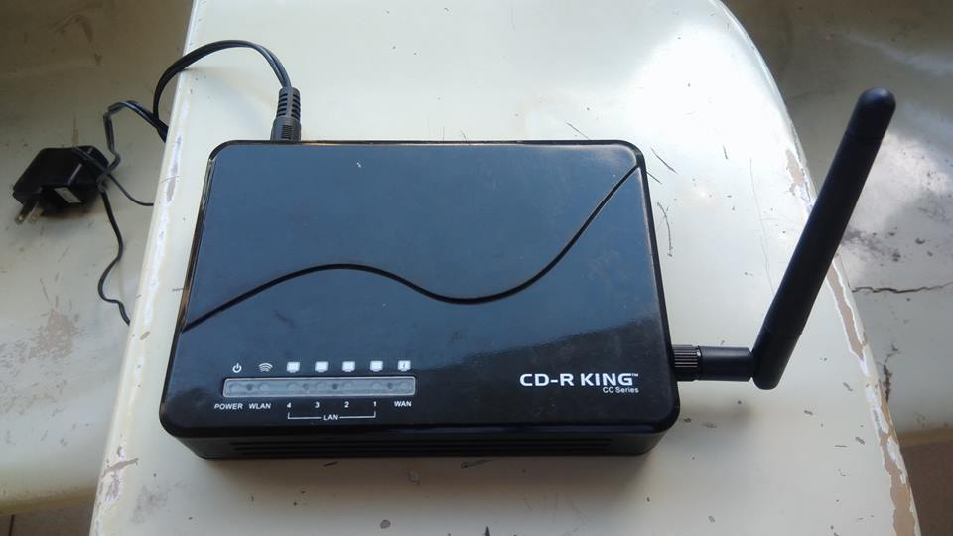

**Figure 50** CD-R King DD-WRT Flashed Router

**Figure 51** Raspberry Pi Model B+

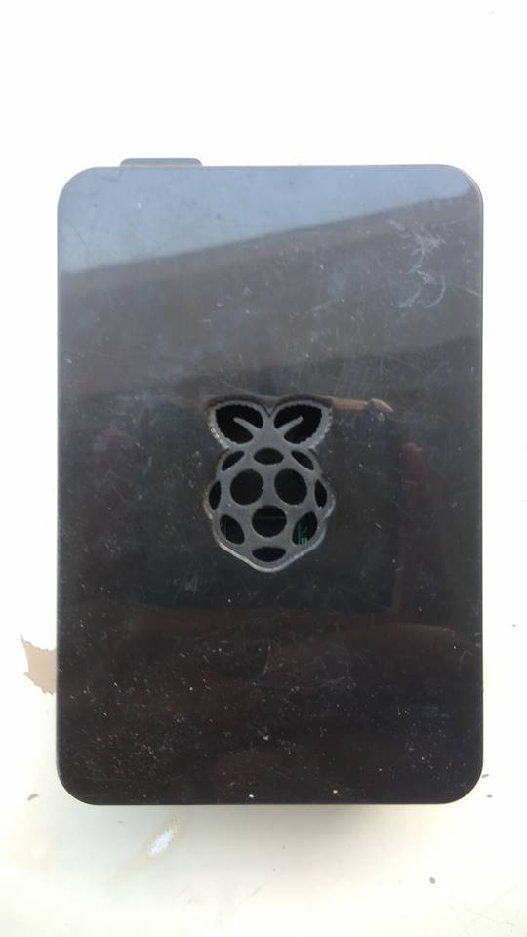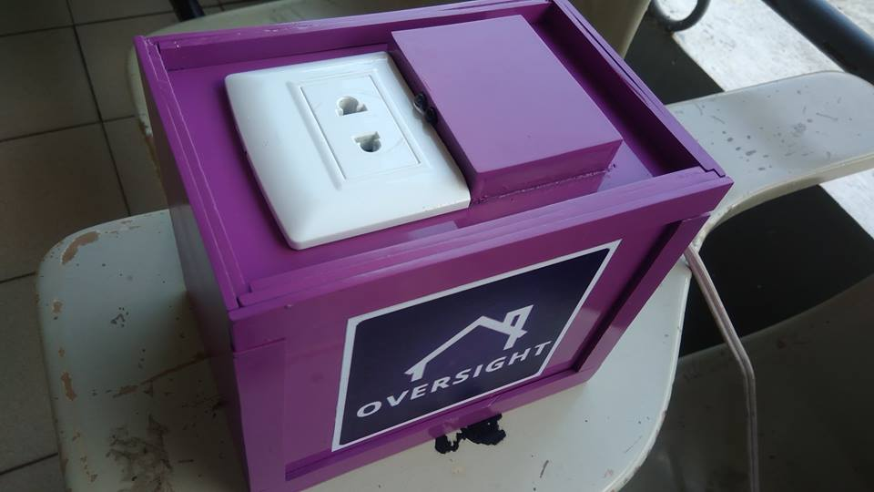

**Figure 52** Power Socket Unit

**Project Assembly:**

1. Plug the Power Socket Unit in a power outlet. The power socket unit should produce beep sound once the initialization completes.
2. Connect the Router to the modem and then plug it to a power outlet then turn it ON.
3. Plug the Raspberry Pi into a power outlet and turn it ON.
4. Please wait 2 to 3 minutes for the system to fully boot.

**Notes:**

1. If you can’t broadcast your server on the internet, contact your Internet Service Provider (ISP) and ask them to enable Port-Forwarding on your Home Internet.

**Usage Guide**

1. Using your browser, go to the web address of the projects’ server that is being port forwarded (The web address depends on the port that is given to you by your ISP). Or you can also use the web mobile application that can be downloaded via Google drive, after downloading the app, it will prompt for the project’s server address. In case of typographical errors, you can re-input the server address by tapping the home oversight logo 10 times.

Download Link: gg.gg/oversightapp QR Code:

1. Register for a user account.
2. After user registration you now have access to the system. You can now register an appliance.
3. To register an appliance, simply plug it in to the power socket unit and it will notify you in the app. You have three choices Register, Allow or Ignore. Just tap register and fill-up the required fields.
4. Refer to figures 53-63 to be familiarized with the web mobile application functions.

**Troubleshooting Guide**

|  |  |
| --- | --- |
| **Power Socket Data wont update** | Make sure that the Router Access Point is turned on. Restart the Power socket by doing a power cycle. |
| **Cannot Access the server address** | Make sure that the router is connected to the modem that has access to the internet. |
| **RFID won’t read when Appliance is plugged in** | Remove the plugged in appliance. Always put the RFID before plugging the device in. |

**User Interface Manual**

3

2

1



**Figure 53** Server Configuration Input Interface

1. Server Address Input Field – This textfield is used for inputting the server address.
2. Save Config Button – Tap to save server address.
3. Back Button – Go back to previous page.

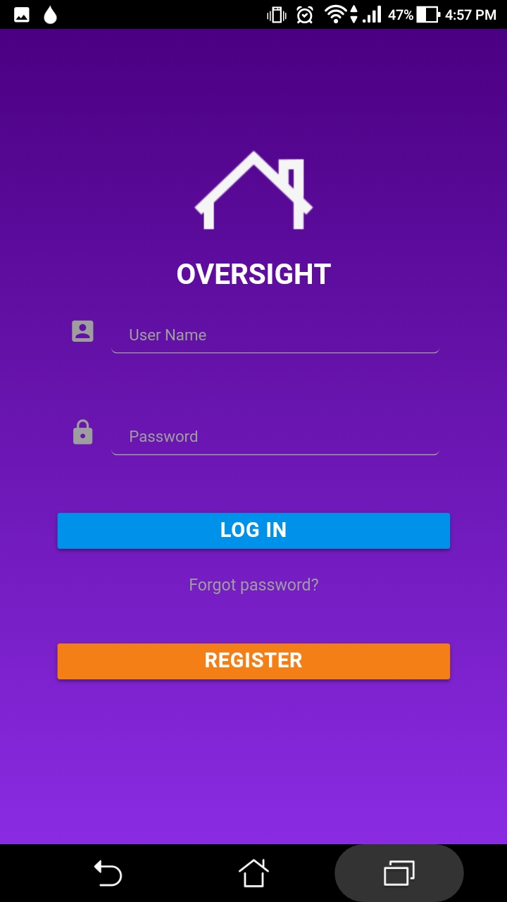

1

2

3

**Figure 54** Login Interface Parts

1. Login Button – Tap login button after you input your username or password
2. Forgot Password - Reset user’s password in case they forgotten it.
3. Register Button – Tap this button if you want to register for an account.



1

2

3

4

5

6

8

7

9

10

11

**Figure 55** Features Drawer

1. Home Oversight Logo – Tap 10 times to change server address.
2. Home – Tap to go to Home Interface
3. Overall Statitistics – Tap to view the overall statistics Interface
4. Notifications – Tap to view notifications
5. How To – Tap to show Set-up Device, Registration and Tips interface
6. Set-up Device – Tap to show tutorial on how to setup the device.
7. Registration – Tap to show tutorial on how to register an appliance
8. Tips – Tap to show some tips on how to save electricity
9. General Settings – Tap to show general settings interface
10. Account Settings – Tap to show account settings interface.
11. Logout – Tap if the user wants to logout.

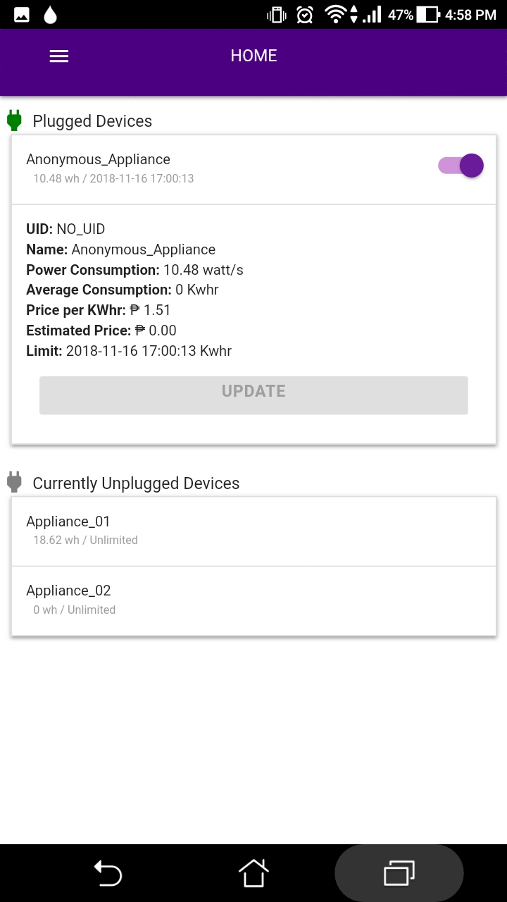

1

2

3

**Figure 56** Home Interface Parts

1. Plugged Devices – Shows the current plugged in appliance information
2. Update Button – Tap to update the Appliance settings.
3. Currently Unplugged Devices – Show the registered but inactive Appliances.

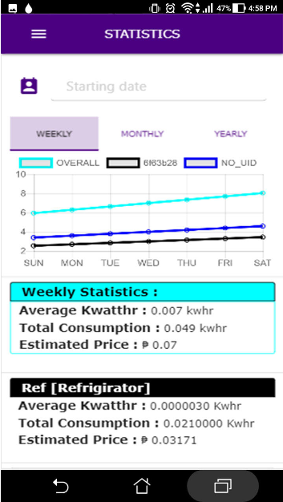

1

2

3

4

**Figure 57** Overall Statitistics Parts

1. Starting Date – Tap to change starting date.
2. Range Picker – Tap to change the range of the graph.
3. Consumption Graph – Shows the consumption of every appliance in a graphical format.
4. Per Appliance Statistics – Shows the consumption of each appliance on a specified date range.



1

2

**Figure 58** Notification Interface Parts

1. New Notifications – Shows new notifications.
2. Earlier Notifications – Shows stacks of past notifications.



1

3

2

**Figure 59** Set-up Device Interface Parts

1. Step Number – Displays step number.
2. Left Arrow – Go back to previous page.
3. Right Arrow – Go to the next page.



1

2

3

**Figure 60** Appliance Registration Interface Parts

1. Step Number – Display step number
2. Left Arrow – Go back to previous page.
3. Right Arrow – Go to the next page.

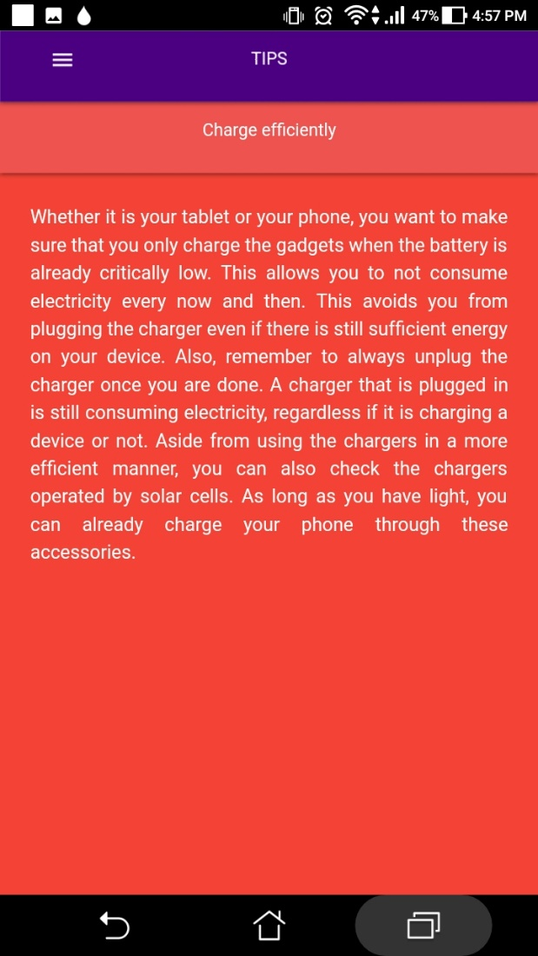

1

2

**Figure 61** Tips Interface Parts

1. Tip Title – Displays the tip title.
2. Tip Content – Displays further information on how to lessen electricity consumption.



1

2

3

4

5

**Figure 62** General Settings Interface Parts

1. Socket Toggle Button – Turn the socket’s power ON/OFF
2. Consumption Limit Toggle Button – Enable/disable consumption limits.
3. Device Authentication – When turned ON, the power socket unit will not allow unregistered appliances to access electricity.
4. Rates – Change Per Kw/H rate if needed.
5. Change Admin Pass – Change admin password option. The default password is 1234



1

2

3

**Figure 63** Account Settings Interface Parts

1. Update Password – Tap to update your password.
2. Update Email – Tap to update registered email.
3. Update Contact Number – Tap to update registered mobile number.

## **Appendix E**

### *(Power Socket Parts)*

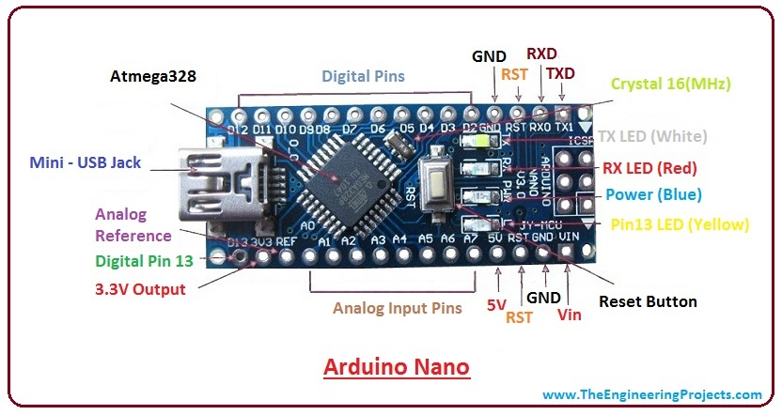

**Figure 64** Arduino Nano V3

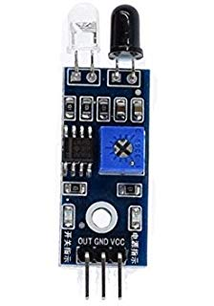

**Figure 65** IR Sensor (Obstruction)

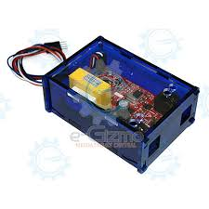

**Figure 66** e-gizmo AC Power Analyzer MK II with Case

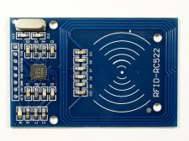**Figure 67** RFID Module (MIFARE)

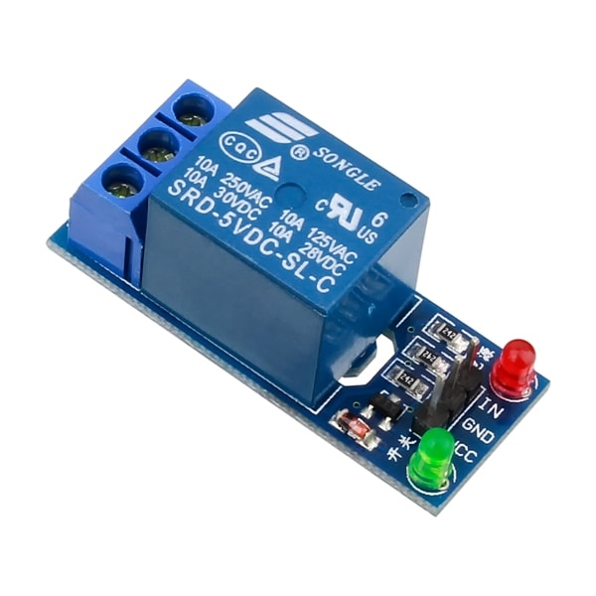**Figure 68** Relay Module 1 Channel

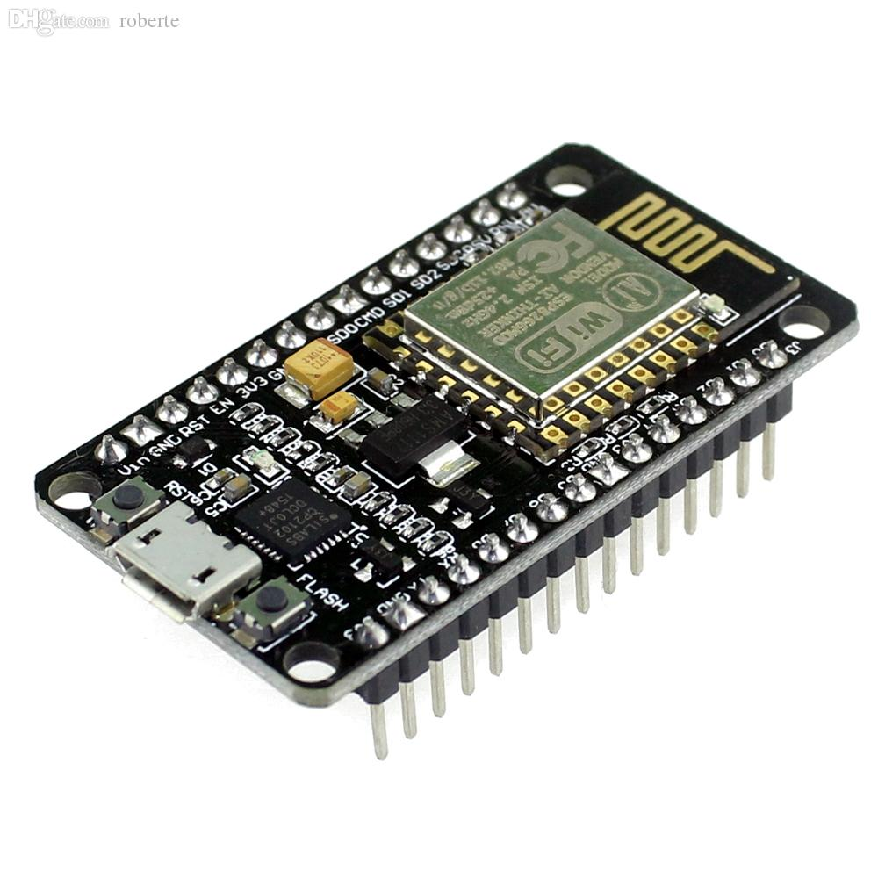**Figure 69** Wireless Module Node MCU

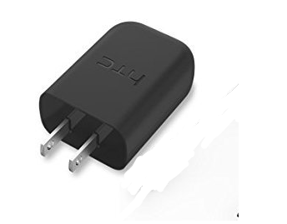

**Figure 70** Mobile Phone Charger

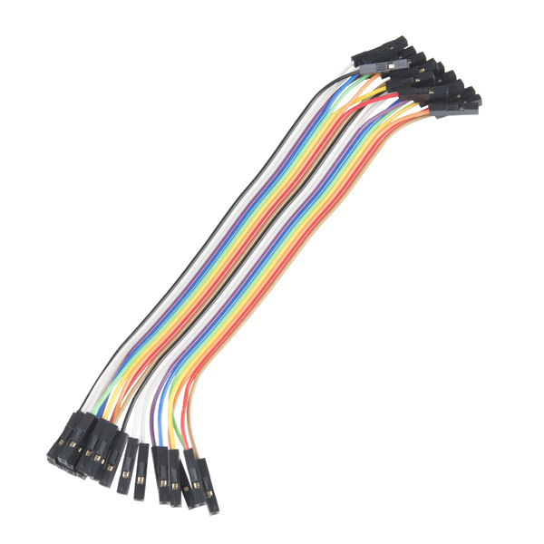

**Figure 71** Jumper Wires Female to Female

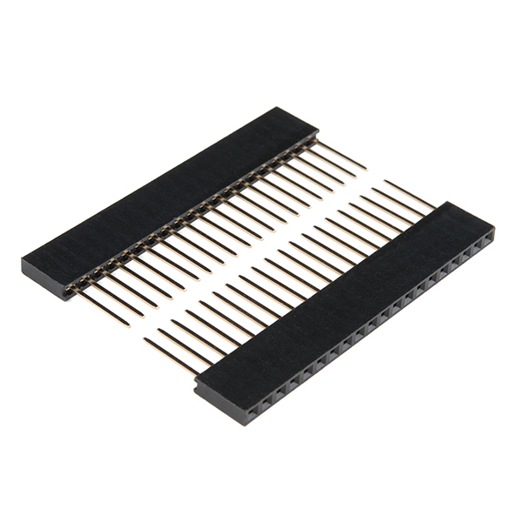**Figure 72** Pin Headers

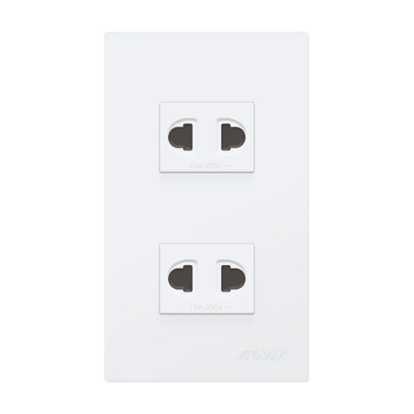**Figure 73** Power Socket

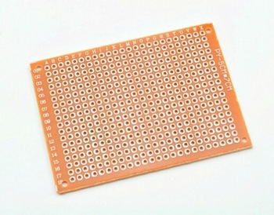

**Figure 74** Universal PCB



**Figure 75** Acrylic Sheets (for the Casing)

## **Appendix F**

### *(Evaluation Tools)*

**Evaluation Criteria for Software**

|  |  |  |  |  |  |
| --- | --- | --- | --- | --- | --- |
| **INDICATORS** | **5** | **4** | **3** | **2** | **1** |
| **A.Functionality** |  |  |  |  |  |
| 1. **Suitabiality**. Functions are appropriate to specifications. |  |  |  |  |  |
| 1. **Accurateness**. Functions are correct. |  |  |  |  |  |
| 1. **Interoperability**. Software can interact with other components or systems. |  |  |  |  |  |
| 1. **Compliance**. Adherence to standards. |  |  |  |  |  |
| 1. **Security**. Provision for security requirements. |  |  |  |  |  |
| **B. Reliability** |  |  |  |  |  |
| 1. **Maturity**. Absence of failures. |  |  |  |  |  |
| 1. **Fault** **tolerance**. Ability to withstand and recover from component failure. |  |  |  |  |  |
| 1. **Recoverability**. Ability to bring back a failed system to full operation, including data and network connections. |  |  |  |  |  |
| 1. **Correctness**. Ability to produce correct computations, output or reports. |  |  |  |  |  |
| **C. Usability** |  |  |  |  |  |
| 1. **Understandability**. Ease of which the systems functions can be understood |  |  |  |  |  |
| 1. **Learnability**. Learning effort for different users, i.e. novice, expert, casual etc. |  |  |  |  |  |
| 1. **Operability**. Ability of the software to be easily operated by a given user in a given environment. |  |  |  |  |  |
| 1. Provision for comfort and convenience. |  |  |  |  |  |
| **D. Maintainability** |  |  |  |  |  |
| 1. **Analyzability**. Ability to identify the root cause of a failure within the software. |  |  |  |  |  |
| 1. **Changeability**. Software adjusts well to different screen dimensions, color depths, and font sizes. Different interfaces can be chosen to suit beginners and more advanced users. |  |  |  |  |  |
| 1. **Stability**. Characterizes the sensitivity to change of a given system. |  |  |  |  |  |
| **E. Portability** |  |  |  |  |  |
| 1. **Adaptability**. Ability of the system to change to new specifications or operating environments. |  |  |  |  |  |
| 1. **Installability**. Are there different options available for installation? Is software easy to install? |  |  |  |  |  |
| 1. **Replaceability**. Ease of exchanging a given software component within a specified environment and system coupling. |  |  |  |  |  |
| 1. **Software compatibility**. Provision for portability of operating system used. |  |  |  |  |  |
| 1. **Build environment portability.** Absence of other software requirement such as runtime system or standard database management engine. |  |  |  |  |  |
| **F. Training and Documentation** |  |  |  |  |  |
| 1. Availability of guides and printed documentation (technical or user’s manual). |  |  |  |  |  |
| 1. Provision for trainings/tutorials or real interactive learning. |  |  |  |  |  |
| 1. Provision for help component. Text should be clear and use language correctly, with appropriate headings and subheadings. Unfamiliar terms should be defined and explained. Organization should be logical. All information should be readily accessible for reference |  |  |  |  |  |

**Evaluation Criteria for Hardware**

|  |  |  |  |  |  |
| --- | --- | --- | --- | --- | --- |
| **INDICATORS** | **5** | **4** | **3** | **2** | **1** |
| **A. Functionality** |  |  |  |  |  |
| 1. **Suitability**. Functions are appropriate to specifications. |  |  |  |  |  |
| 1. **Accurateness**. Functions are correct. |  |  |  |  |  |
| 1. **Interoperability**. Prototype can interact with other components or systems. |  |  |  |  |  |
| 1. **Compliance**. Adherence to industry standards for similar hardware components. |  |  |  |  |  |
| 1. **Security**. Provision for security requirements. |  |  |  |  |  |
| **B. Reliability** |  |  |  |  |  |
| 1. **Maturity**. Absence of failures. |  |  |  |  |  |
| 2. **Fault** **tolerance**. Ability to withstand and recover from component failure. |  |  |  |  |  |
| 1. **Recoverability**. Ability to bring back a failed system to full operation, including data and network connections. |  |  |  |  |  |
| **C. Usability** |  |  |  |  |  |
| 1. **Understandability**. Ease of which the systems functions can be understood. |  |  |  |  |  |
| 1. **Learnability**. Learning effort for different users, i.e. novice, expert, casual etc. |  |  |  |  |  |
| 1. **Operability**. Ability of the prototype to be easily operated by a given user in a given environment. |  |  |  |  |  |
| 1. Provision for comfort and convenience. |  |  |  |  |  |
| **D. Maintainability** |  |  |  |  |  |
| 1. **Analyzability**. Ability to identify the root cause of a failure within the prototype. |  |  |  |  |  |
| 1. **Stability**. Characterizes the sensitivity to change of a given system. |  |  |  |  |  |
| 1. **Testability**. Characterizes the effort needed to verify (test) a system change. |  |  |  |  |  |
| 1. Can hardware be serviced, maintained, and upgraded locally? |  |  |  |  |  |
| **E. Portability** |  |  |  |  |  |
| 1. **Adaptability/Mobility**. Ability of the system to change to new specifications or operating environments. |  |  |  |  |  |
| 1. **Installability**. Are there different options available for installation? Can hardware be installed and maintained by local staff persons. |  |  |  |  |  |
| 1. **Replaceability**. Ease of exchanging a given prototype component within a specified environment. |  |  |  |  |  |
| 1. Appropriateness of size and weight suitability. |  |  |  |  |  |
| **F. Workability** |  |  |  |  |  |
| 1. **Availability of materials**. Consideration must be given to whether a line of equipment is being discontinued; what implications does the discontinuance have on issues such as maintenance. |  |  |  |  |  |
| 1. Availability of technical expertise. |  |  |  |  |  |
| 1. Availability of tools and machines. Provision for diagnostic tools and procedures. |  |  |  |  |  |
| **G. Safety** |  |  |  |  |  |
| 1. Absence of toxic or hazardous materials. |  |  |  |  |  |
| 1. Absence of sharp edges. |  |  |  |  |  |
| 1. Provision for protection against harmful or dangerous events/objects. |  |  |  |  |  |
| **H. Training and Documentation** |  |  |  |  |  |
| 1. Availability of guides and printed documentation (technical or user’s manual). |  |  |  |  |  |
| 1. Provision for trainings/tutorials or real interactive learning. |  |  |  |  |  |
| 1. Provision for help component. Text should be clear and use language correctly, with appropriate headings and subheadings. Unfamiliar terms should be defined and explained. |  |  |  |  |  |